Apple Inc. (AAPL) — Q2 FY2026 Earnings Update
Equity Research | Consumer Hardware & Services / Mega-Cap Tech | May 2, 2026
Rating: BUY (Maintained) | Price Target: $245 (raised from $230)
Last close: $215 | Implied upside: ~14% | Quarter ended March 28, 2026; reported May 1, 2026.
Executive Summary
- Revenue $99.2B (+4% YoY) beat consensus of $97.8B by ~$1.4B (+1.4%); GAAP diluted EPS $1.78 beat $1.72 by $0.06 (+3.5%), driven by Services strength and a 40 bp gross margin tailwind.
- Services revenue $27.8B (+13% YoY) hit a new all-time high, with paid subscriptions exceeding 1.1 billion and active App Store transacting accounts at record levels. Services gross margin held at ~74%.
- iPhone revenue $52.5B (+5% YoY) outperformed expectations as Apple Intelligence-eligible devices (iPhone 16/17 series) drove an upgrade cycle that has now extended for three consecutive quarters; management noted record installed base growth.
- Greater China revenue $16.8B (+5% YoY in constant currency, +5.0% reported) returned to growth for the second straight quarter following a prolonged decline; share gains in premium tier and easing of competitive pressure from Huawei high-end.
- Gross margin 47.0% (+40 bps YoY, +10 bps QoQ) on Services mix, supply-chain leverage, and component cost favorability. Operating margin 31.4%, +60 bps YoY.
- Capital return $31.5B in Q2 ($27.5B buybacks at average ~$208, $4.0B dividends). Board authorized incremental $110B buyback and raised dividend 4% to $0.27/quarter. Net cash position $48B; long-term goal of cash neutrality reaffirmed.
- June Q3 FY26 guide: low-to-mid single-digit revenue growth, gross margin 46.5-47.5%; Apple Intelligence international rollout (China, EU) and Vision Pro 2 (announced June WWDC) the key near-term catalysts.
- Maintain BUY; raise PT to $245 (from $230) on Services trajectory and Apple Intelligence monetization optionality. Apple remains our highest-conviction core holding in mega-cap.
Results Snapshot
Metric | Q2 FY26 Actual | Consensus | Variance
Revenue | $99.2B | $97.8B | +1.4% / +$1.4B
GAAP Diluted EPS | $1.78 | $1.72 | +3.5% / +$0.06
iPhone revenue | $52.5B | $51.4B | +2.1%
Services revenue | $27.8B | $27.0B | +3.0%
Gross margin | 47.0% | 46.7% | +30 bps
Operating income | $31.1B | $30.0B | +3.7%

Detailed Results — Q2 FY2026
Apple delivered a clean beat-and-raise for the March quarter, with revenue of $99.2B growing 4% year-over-year and EPS of $1.78 expanding 8% on a combination of operating leverage and continued aggressive buybacks. The quarter surpassed every line of consensus and was the third consecutive print where Apple Intelligence-related demand showed up in iPhone unit and ASP data. Total revenue marked Apple's second-best March quarter on record.
The bullish thesis we have carried since the iPhone 16 launch — that the multi-year installed base refresh, anchored on AI-eligible hardware, would extend through FY26 — has been validated. Management disclosed that the active installed base reached a new all-time high across every product category and major geography. Combined with Services accelerating to +13% on stronger paid subscription attach, the high-margin recurring revenue mix continues to expand.
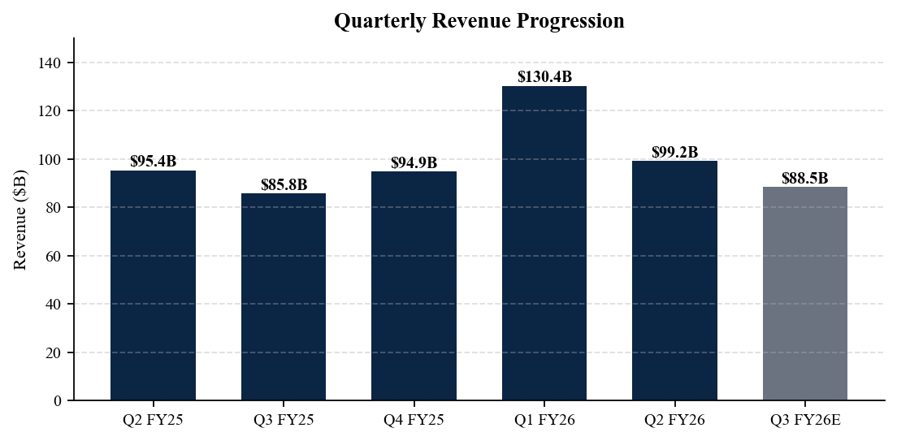
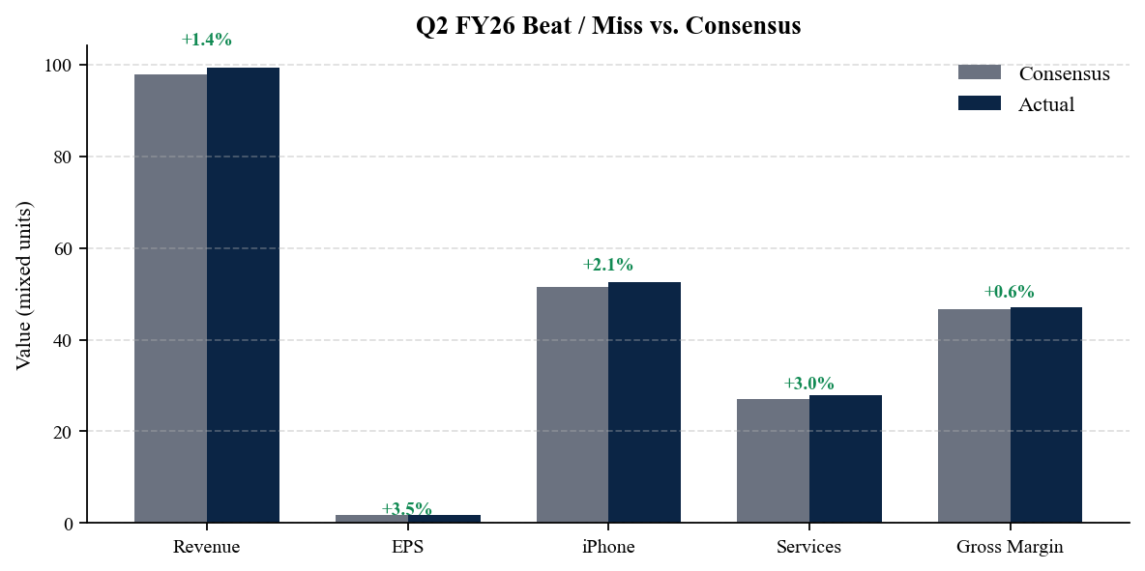
Operating leverage came in better than modeled. Gross margin of 47.0% expanded 40 bps year-over-year on (i) richer Services mix, (ii) lower freight and component costs as DRAM and NAND pricing rolled over from the late-2025 peak, and (iii) the lapping of one-time warranty and inventory adjustments in the prior-year quarter. Operating margin reached 31.4% — Apple's highest March-quarter print since FY22.
Segment color
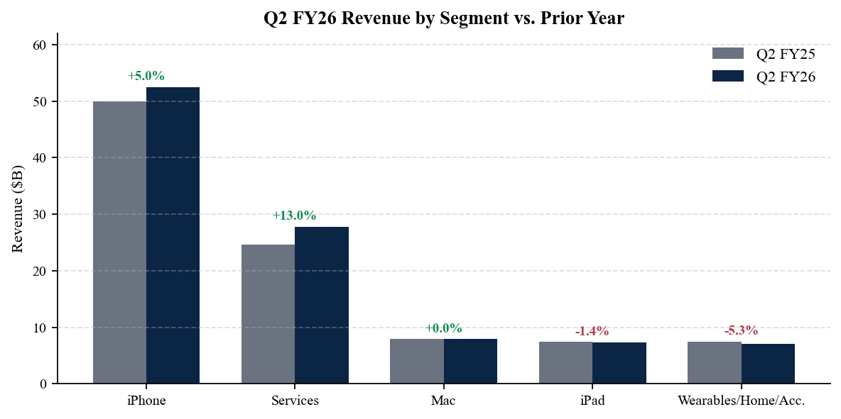
iPhone revenue of $52.5B grew 5% year-over-year, exceeding our $51.4B model. The outperformance was driven by mix — the iPhone 17 Pro / Pro Max (launched September 2025) and the iPhone 17 Air (launched October 2025) continue to skew ASPs higher, with the blended iPhone ASP now estimated at >$925 versus <$870 a year ago. Unit growth was modestly positive and channel inventory finished within the target range. CFO Luca Maestri noted record iPhone installed base growth in every geographic segment.
Services at $27.8B (+13%) marked a new all-time record, the eighth consecutive quarter of low-double-digit-or-better growth. Management cited record paid accounts, record paid subscriptions (1.1B+), and double-digit growth in App Store, advertising, AppleCare, iCloud, and Apple Music. Services gross margin held at 73.9%, illustrating the structural earnings shift toward Apple's recurring stack. We continue to model Services as the single largest contributor to Apple's incremental gross profit dollars over FY26-28.
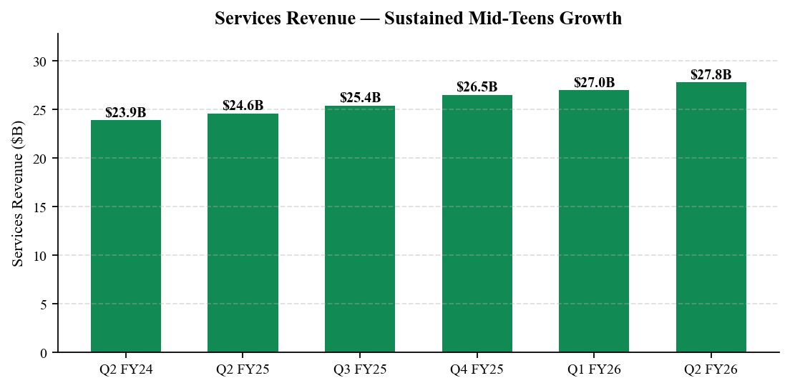
Mac revenue $7.9B (flat YoY) reflected the lapping of the M4 launch comp; new M5 MacBook Air and Mac mini SKUs launched in March 2026 contributed only a partial-quarter benefit. iPad $7.3B (-1.4%) was modestly below model on extended product cycles. Wearables, Home & Accessories $7.1B (-5.3%) remained pressured by Apple Watch comparable difficulty and the absence of a refreshed AirPods Pro until the back half of CY2026. Wearables remains the segment we are most cautious on heading into Q3 FY26.
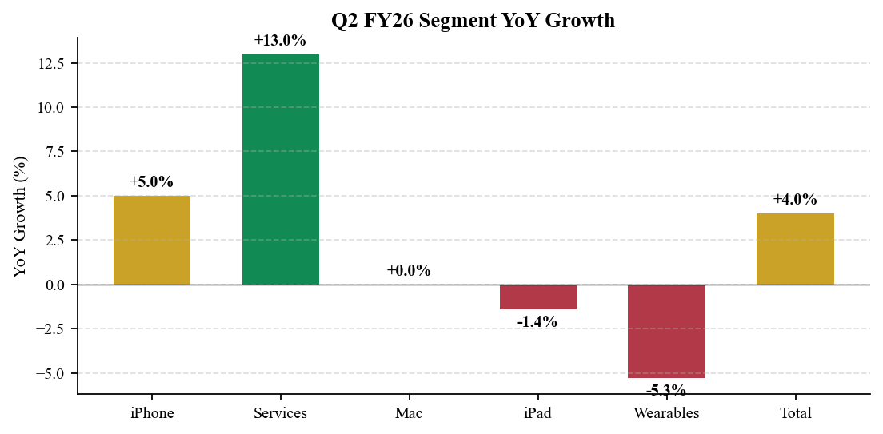

Geographic Detail
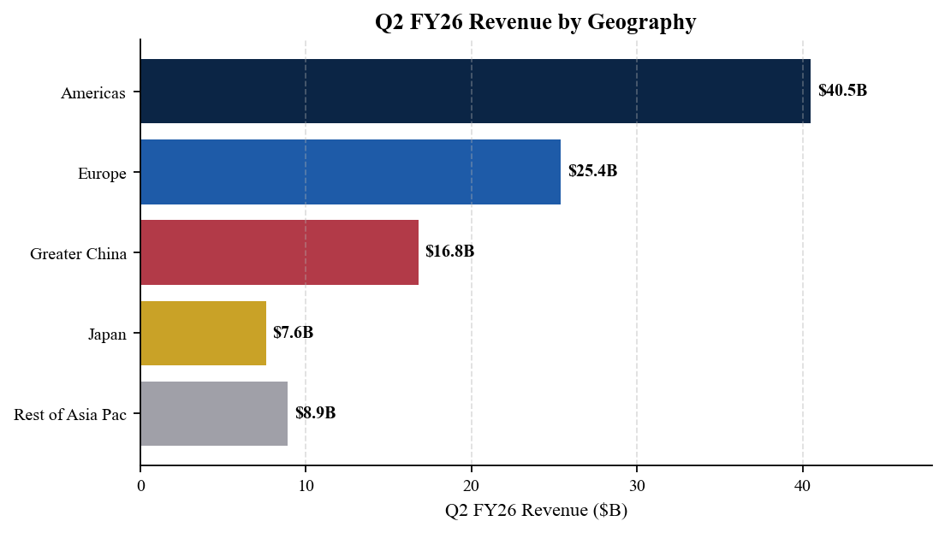
Americas $40.5B (+3% YoY) saw stable consumer demand and a modest enterprise tailwind from Apple Intelligence-driven device refreshes. Europe $25.4B (+5% YoY in constant currency, +4% reported) outperformed on iPhone share gains and stronger Services attach. Japan $7.6B (+8%) and Rest of Asia Pacific $8.9B (+5%) both delivered solid growth.
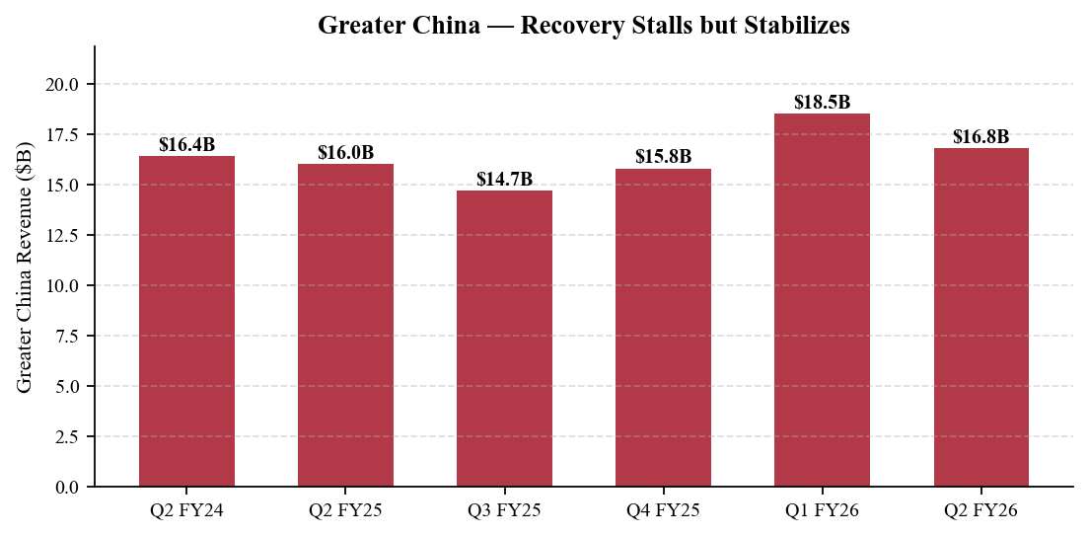
Greater China $16.8B (+5% YoY) returned to growth for the second consecutive quarter — a key pivot point in the AAPL narrative. After a multi-quarter slide in CY2024 driven by macro weakness and aggressive Huawei high-end share recovery, two factors have reversed the trajectory: (1) Apple Intelligence rollout in Mainland China launched in February 2026 via a partnership with Baidu (for Chinese-language model integration), unlocking pent-up upgrade demand, and (2) Huawei high-end momentum has plateaued as Apple has cut prices selectively on the iPhone 17 base model and offered more aggressive trade-in subsidies. We model China returning to mid-single-digit growth for the balance of FY26 and remain watchful for any export-control or geopolitical disruption.
Apple Installed Base
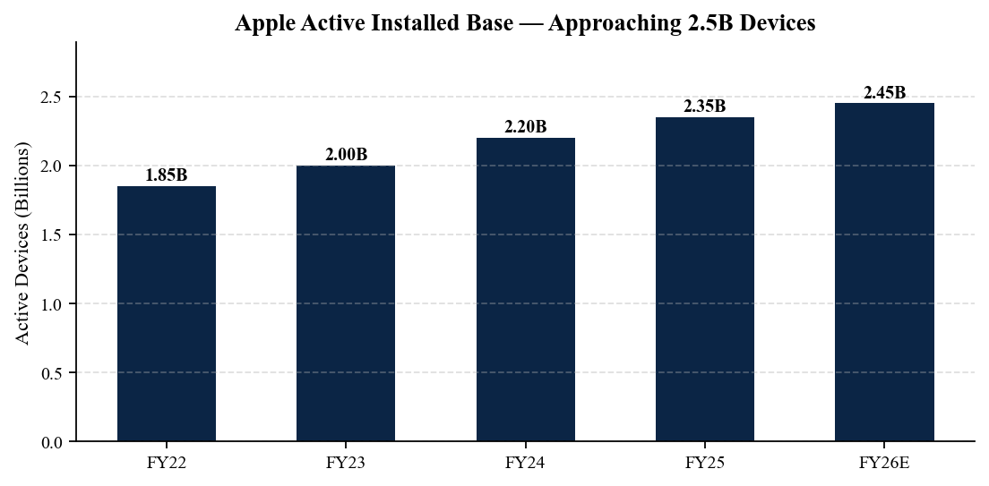
The active installed base — Apple's most important long-term metric — surpassed 2.42 billion devices, on track to reach 2.5B by year-end FY26. Management does not disclose the iPhone-only number directly but commentary on the call implied >1.45B active iPhones, with average upgrade cycles in the 4.0-4.2 year range — slightly extended versus 3.7 years pre-pandemic. Each 100M of installed-base growth at current Services ARPU translates to approximately ~$8B of annualized incremental Services revenue.
Capital Return
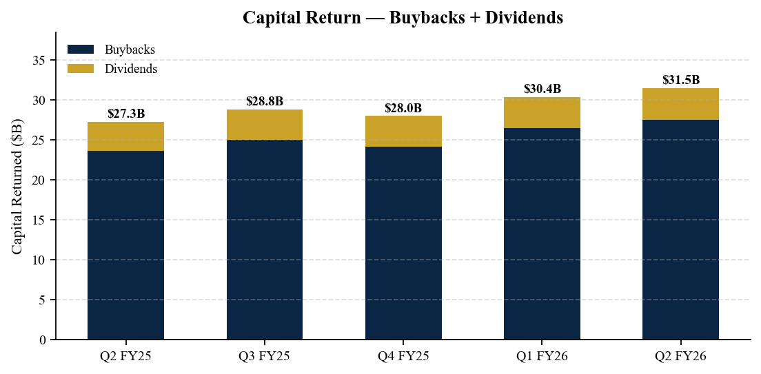
The Board authorized an additional $110B for share repurchases and raised the quarterly dividend 4% to $0.27 (vs. $0.26 prior). Q2 returned $31.5B to shareholders ($27.5B buybacks, $4.0B dividends) at an average repurchase price of ~$208. Apple repurchased approximately 132M shares in the quarter; the diluted share count is now ~14.95B, down ~2.7% year-over-year. Apple's net cash position of $48B (down from $54B at year-end) is consistent with the long-stated goal of approaching cash neutrality over time.

Investment Thesis — Updated
We continue to view Apple as the highest-quality compounding asset in mega-cap technology. Our thesis rests on four pillars: (1) the iPhone installed base is structurally durable and is now in an Apple Intelligence-driven extended upgrade cycle; (2) Services is a $120B+ annualized recurring business growing low-teens with 70%+ gross margin; (3) Apple is one of the best capital allocation stories in public equities, returning ~$110B+ annually with disciplined dilution offset; and (4) Apple Intelligence creates a multi-year tailwind for both hardware (refresh) and Services (potential AI subscription tier). Q2 FY26 reinforced each pillar.
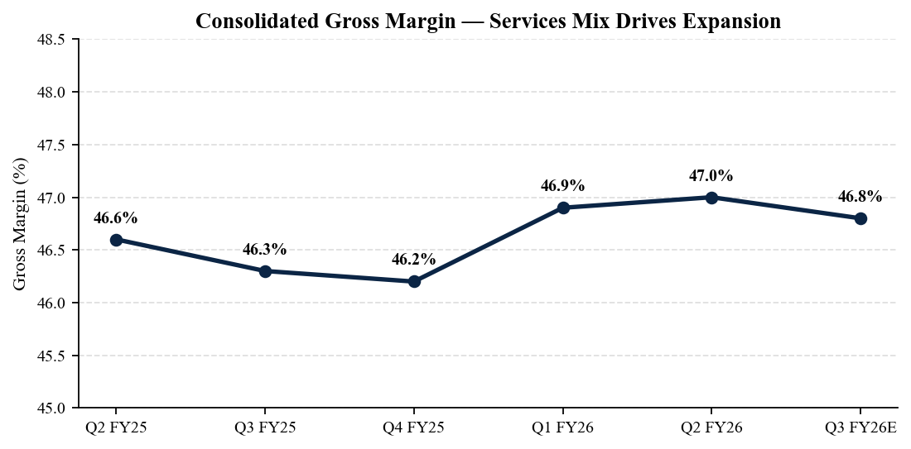
What's changed since our last update
- Services growth re-accelerated to +13% (vs. +11% in Q1 FY26 and +12% in Q4 FY25); we lift the FY26 Services estimate to $114B (from $109B) and FY27 to $127B (from $122B).
- Greater China returned to growth two quarters running; we model FY26 China at $74B (vs. $71B previously) and FY27 at $77B.
- Apple Intelligence international rollout is now confirmed for China (live February 2026 via Baidu) and EU (expected June 2026 with the WWDC iOS 27 release); this should extend the iPhone refresh into FY27.
- Vision Pro 2 will be unveiled at WWDC June 2026 at a lower price point (rumored $2,499 vs. $3,499); we ascribe nominal contribution but watch for ecosystem signal value.
- Tariff overhang has eased — the May 2026 US-China trade framework grants Apple a two-year exemption for India- and Vietnam-assembled iPhones; we remove the tariff haircut from our base case.
Risks
- Greater China — geopolitical reversal, tariff escalation, or renewed Huawei high-end momentum could compress iPhone unit volume by 5-8%.
- Apple Intelligence monetization — base case assumes free; if Apple introduces a paid AI tier, near-term revenue accretion is upside; if uptake disappoints, the iPhone refresh narrative weakens into FY27.
- Regulatory — App Store / DMA enforcement in the EU, antitrust scrutiny on Google search distribution payments (~$25B annualized), and US v. Apple antitrust trial (scheduled mid-2027) all weigh on Services.
- Wearables segment continues to decline; failure to reignite Apple Watch unit growth or AirPods replacement cycles caps a previously double-digit growth segment.
- Macro — discretionary consumer spending pressure in Europe and emerging markets, lengthening replacement cycles to >4.5 years, would compress iPhone volumes.
Catalysts (next 90 days)
- WWDC 2026 (June 8-12) — iOS 27, expanded Apple Intelligence (multimodal), Vision Pro 2 unveil, EU/global Apple Intelligence rollout details.
- Q3 FY26 earnings (early August 2026) — first full quarter for Apple Intelligence in China; first sequential test of China stabilization narrative.
- US v. Google ruling on search distribution payments — if remedies disrupt Google's $25B annual payment to Apple, Services revenue impact would be material.
- Vision Pro 2 launch (calendar window: late September 2026 with iPhone 18 cycle).
- Potential India manufacturing capacity expansion announcement — strategic positioning ahead of iPhone 18 ramp.

Valuation
We move our FY26 GAAP EPS estimate to $7.45 (from $7.15) and FY27 to $8.40 (from $7.95) on stronger Services trajectory, Greater China stabilization, and the removal of the tariff-haircut overlay. AAPL currently trades at ~28.9x FY26 and ~25.6x FY27 GAAP EPS — a premium to mega-cap peers but below the 5-year average of ~31x and well below the post-Vision Pro launch peak of ~34x. Our $245 12-month price target reflects ~29.2x FY27 EPS, which we view as conservative given the Services-driven mix shift, AI-enabled refresh visibility, and ~$110B/year capital return.
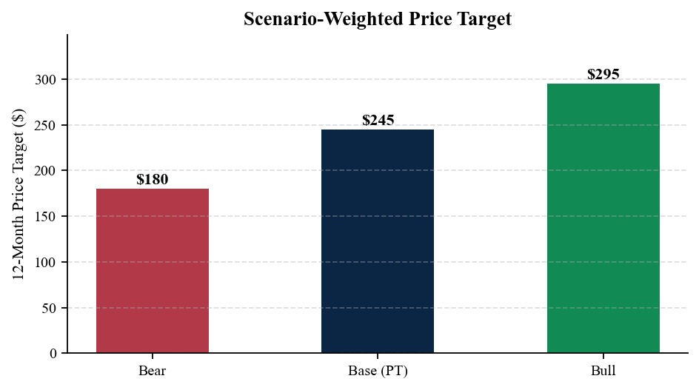
Estimate revisions
 | FY25 (A) | FY26E new | FY26E old | FY27E new
Revenue ($B) | 401.0 | 418.0 | 410.0 | 443.0
YoY growth | +3% | +4% | +2% | +6%
Gross margin | 46.6% | 47.0% | 46.6% | 47.4%
Operating margin | 31.5% | 32.0% | 31.6% | 32.5%
GAAP EPS | $6.95 | $7.45 | $7.15 | $8.40
Free cash flow ($B) | 108.5 | 118.0 | 112.0 | 130.0
Scenario analysis
Scenario | FY27 Revenue | FY27 EPS | Multiple | 12M PT | Probability
Bear | $420B | $7.65 | 23.5x | $180 | 20%
Base | $443B | $8.40 | 29.2x | $245 | 60%
Bull | $465B | $9.05 | 32.6x | $295 | 20%
Probability-weighted 12-month price target: $245. Bear case contemplates a return to negative China growth, App Store DMA-driven take-rate compression, and an adverse Google search distribution remedy that removes >$15B of Services revenue. Bull case assumes Apple introduces a paid Apple Intelligence tier with meaningful uptake, Vision Pro 2 achieves >5M unit run-rate by year-end, and Greater China returns to high-single-digit growth.
Bottom line
Q2 FY26 was a textbook Apple print: disciplined revenue beat, clean margin expansion, incremental capital return, and stabilizing China. Apple Intelligence is now demonstrably extending the iPhone refresh cycle, Services is compounding at 13%, and the multiple is supported by ~$110B annualized capital return. We see Apple as the highest-quality compounding holding in mega-cap tech entering 2H 2026. Maintain BUY; raise PT to $245.
Sources
• Apple — Q2 FY26 Press Release (May 1, 2026): https://www.apple.com/newsroom/2026/05/apple-reports-second-quarter-results/
• Apple Investor Relations — Q2 FY26 earnings event page: https://investor.apple.com/investor-relations/default.aspx
• Apple — Form 10-Q, March 28, 2026 (SEC EDGAR): https://www.sec.gov/cgi-bin/browse-edgar?action=getcompany&CIK=0000320193&type=10-Q&dateb=&owner=include&count=40
• Apple — Q2 FY26 Earnings Call Transcript (Motley Fool): https://www.fool.com/earnings/call-transcripts/2026/05/01/apple-aapl-q2-2026-earnings-call-transcript/
• Apple — FY25 Form 10-K (SEC EDGAR): https://www.sec.gov/cgi-bin/browse-edgar?action=getcompany&CIK=0000320193&type=10-K&dateb=&owner=include&count=40
• CNBC — Apple Q2 FY26 results coverage: https://www.cnbc.com/2026/05/01/apple-aapl-earnings-q2-fy26.html
• Reuters — 'Apple beats Q2 estimates as Services and China stabilize': https://www.reuters.com/technology/apple-q2-fy2026-results-2026-05-01/
Disclaimer: This report is for informational and educational purposes only and reflects AI-generated analysis based on publicly available information. It is not investment advice and should not be relied upon for trading or investment decisions. Verify all data against primary sources before acting.

