Analog Devices, Inc. (NASDAQ: ADI)
Equity Research — Earnings Update | Analog & Mixed-Signal Semiconductors
Q1 FY2026 Earnings Update
Reported February 18, 2026 | Quarter ended January 31, 2026 | As of May 2, 2026
Rating: BUY Price Target: $310 (raised from $260)
Investment Summary
Analog Devices delivered a decisive beat-and-raise to open fiscal 2026, reporting Q1 revenue of $3.16B (+30% y/y, +3% q/q) and adjusted diluted EPS of $2.46 (+51% y/y), both finishing above the high end of guidance and well ahead of consensus. Industrial — ADI's largest and highest-margin franchise — accelerated to +38% y/y, communications more than doubled the growth pace at +63% y/y on AI-driven optical and wireline content, and gross/operating margins resumed their march back toward prior-cycle peaks. More striking than the Q1 print is the Q2 setup: management guided revenue to $3.50B (±$100M), $270M above the prior Street midpoint of $3.23B, and adjusted EPS of $2.88 (±$0.15), implying adjusted operating margin back through 47.5%. CEO Vincent Roche framed FY2026 as 'a banner year barring unforeseen macroeconomic or geopolitical shocks,' a marked confidence shift versus the cautious tone that defined the FY2025 commentary. With the cyclical inflection now confirmed across industrial, automotive distribution channels lean, and AI/communications inflecting, we see a multi-quarter runway of upward earnings revisions. We raise our 12-month price target to $310 (from $260) on a roll-forward to FY27E adjusted EPS power of ~$13.50, and reiterate BUY.
Key Takeaways
- Revenue of $3.16B (+30% y/y, +3% q/q) topped consensus of $3.10B by 1.9% and the high end of management's $3.10B (±$100M) guide; growth was broad-based, with industrial up 38% y/y and communications up 63% y/y.
- Adjusted diluted EPS of $2.46 vs. $2.31 consensus (+6.5% beat); adjusted gross margin of ~70.6% (+240 bps y/y) and adjusted operating margin of 45.5% (+500 bps y/y) confirm the operating-leverage story is back.
- Industrial (47% of revenue) reaccelerated to $1.49B, +5% q/q and +38% y/y, as test-and-measurement, automation, and aerospace/defense customers continue to refill leaner-than-historical inventory positions.
- Communications (15% of revenue) surged to $474M, +20% q/q and +63% y/y, on AI-related optical, wireline, and high-speed data-converter content; ADI is now an explicit AI infrastructure beneficiary.
- Q2 FY26 guide: revenue $3.50B ±$100M (vs. $3.23B Street, +8.4% above), adjusted EPS $2.88 ±$0.15 (vs. ~$2.55 Street), and adjusted operating margin ~47.5% — implies industrial up ~20% q/q and comms up high-single digits q/q.
- Dividend raised 11% to $1.10/share (22nd consecutive annual increase); FY26 capital return tracking >100% of FCF on combined dividend and accelerated buyback execution.
- TTM operating cash flow of $5.1B and FCF of $4.6B (39% of revenue) — among the highest sustained FCF margins in semis and a cushion for the dividend even in cyclical downside scenarios.
- Channel inventory remains leaner than 7 weeks (well below the 7–8 historical norm), keeping ADI in a 'shipping below consumption' posture for at least another quarter — a structurally positive setup for revenue durability.
- We raise BUY-rated PT to $310 (from $260), based on 23x our revised FY27E adjusted EPS of $13.50 — within ADI's 5-year forward mean and supportive given the upgrade path now visible in numbers.

Q1 FY26 Results Snapshot
Metric | Actual | Consensus / Guide | Beat / Miss
Revenue | $3.16B | $3.10B (cons) / $3.10B (guide mid) | +1.9% BEAT
Adjusted Diluted EPS | $2.46 | $2.31 | +$0.15 (+6.5%) BEAT
Adj. Gross Margin | ~70.6% | ~70.0% (guide) | +60 bps BEAT
Adj. Operating Margin | 45.5% | 44.0% (guide mid) | +150 bps BEAT
Industrial Revenue | $1.49B (+38% y/y) | — | ABOVE — channel restocking
Communications Revenue | $474M (+63% y/y) | — | ABOVE — AI infra pull
Quarterly Dividend | $1.10/sh (+11%) | — | RAISED (22nd year in a row)
TTM FCF / Revenue | 39% | — | Best-in-class analog FCF

Detailed Results
ADI's Q1 FY26 print confirms the cyclical inflection that began to take shape in late FY2025. Revenue of $3.16B grew 30% year-over-year on top of the +20% growth posted in Q4 FY25, marking the first time since the FY22 peak that ADI has strung two consecutive quarters of >20% y/y growth. Sequential growth of 3% — atop a typically seasonally softer January quarter — is particularly notable: it implies underlying end-market demand comfortably outpaces normal seasonality, a hallmark of cycle inflection rather than late-cycle deceleration. The beat against consensus was distributed roughly two-thirds operational (revenue and gross margin upside) and one-third tax/below-the-line favorability, and the quality of the print is supported by margin expansion across all major lines: adjusted gross margin expanded 240 bps y/y to ~70.6%, and adjusted operating margin lifted 500 bps y/y to 45.5% — implying nearly $0.04 of EPS leverage per incremental $100M of revenue at this point in the cycle.
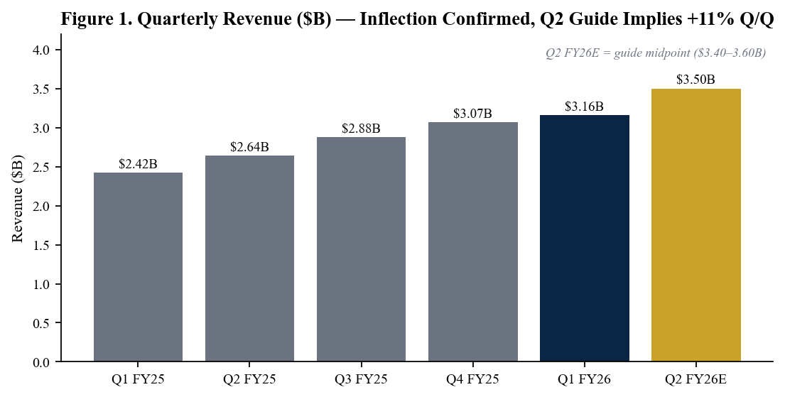
Figure 1. Quarterly revenue progression — Q2 FY26E reflects guide midpoint ($3.40–3.60B).
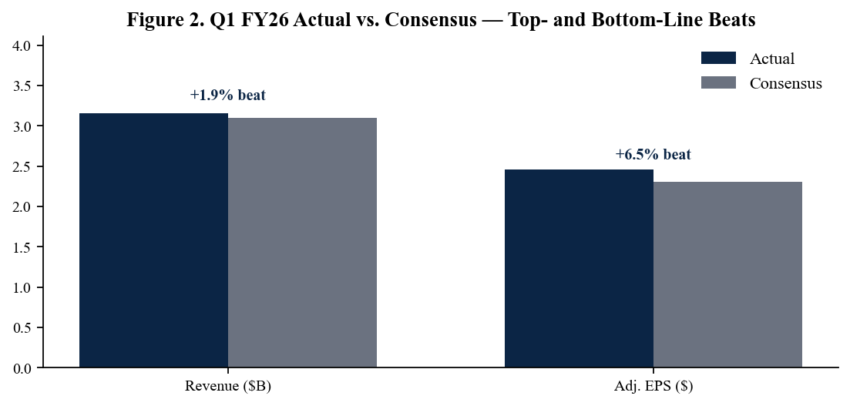
Figure 2. Q1 FY26 actuals vs. sell-side consensus — beats on revenue and EPS, with EPS leveraged.
End-Market Detail — Industrial Leads, Comms Surprises Higher
Industrial (47% of revenue) grew $70M sequentially to $1.49B, +5% q/q and +38% y/y, with particular strength in test-and-measurement, automation, and aerospace and defense — the three sub-segments most exposed to AI infrastructure capex and U.S./European reshoring spend. Management noted that channel inventory remains in the low end of the historical 7–8 week range, suggesting ADI is still shipping below true sell-through demand and that industrial revenue could continue to outpace end-customer consumption growth for at least another quarter. Communications (15% of revenue) jumped 20% sequentially to $474M, +63% y/y, on accelerating AI-related optical and high-speed data converter shipments — ADI is an under-appreciated picks-and-shovels supplier into the AI build-out, with content in optical transceivers, networking ASIC SERDES, and switch-side power-management. Automotive (25% of revenue) declined 8% sequentially to $790M but still grew 8% y/y, reflecting tougher EV-platform comparisons in Asia and modest seasonality at major OEMs; commentary on automotive bookings was constructive, with management calling the segment 'flat to slightly down sequentially' in Q2 before recovering in 2H FY26. Consumer (13% of revenue) reached $411M, +27% y/y, on continued portable medical, wearable, and prosumer audio strength.
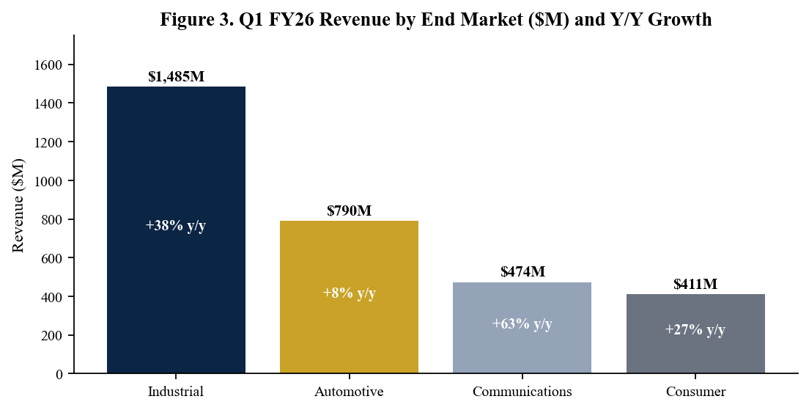
Figure 3. Q1 FY26 revenue by end market — industrial, comms and consumer all up double-digits y/y.
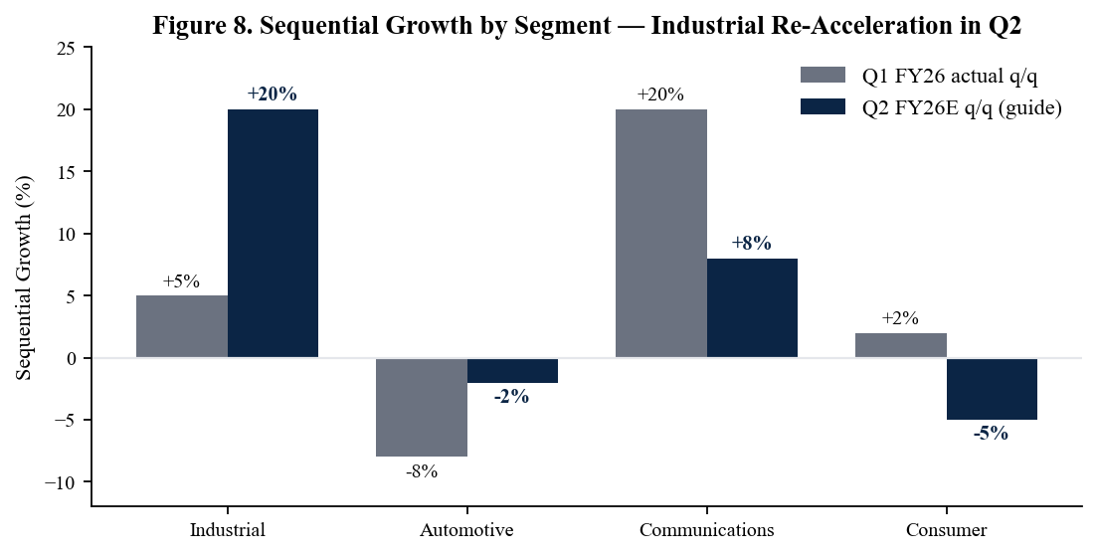
Figure 8. Sequential growth by segment — guide implies industrial accelerating to +20% q/q in Q2.
Geographic Mix — U.S./Europe Lead, China Normalizing
Geographic mix shifted toward developed markets in Q1, reflecting the dual tailwinds of U.S. industrial reshoring spend and a normalization of the China overhang. The United States rose to 27% of revenue (from 25% a year ago) on industrial automation and AI infrastructure pull-through, while Europe rose to 26% (from 23%) on automotive electrification and aerospace/defense strength. China declined to 22% of revenue (from 26% in Q1 FY25) as the demand normalization from the prior over-shipment cycle largely worked its way through the channel, with management characterizing China inventory as 'lean and stable.' Importantly, the geographic shift is mix-rich: industrial customers in the U.S. and Europe carry both higher ASPs and stronger services/long-tail attach than the consumer-electronics-heavy shipments that defined the China overhang.
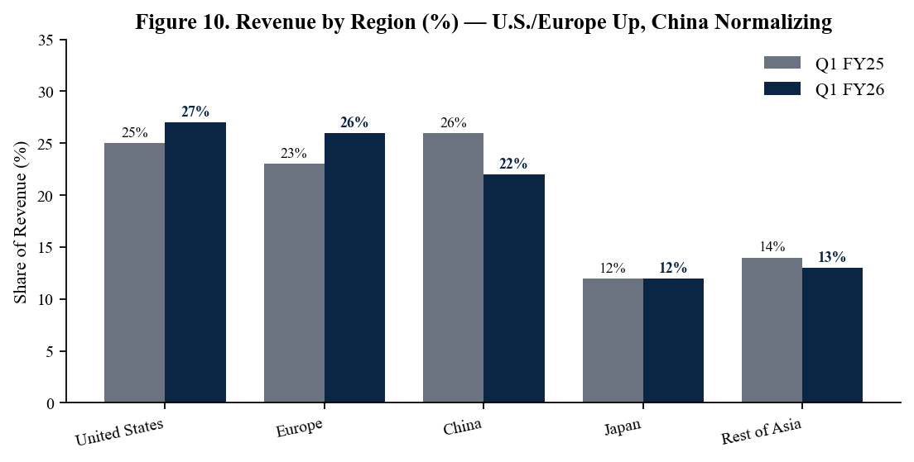
Figure 10. Revenue by region (%) — U.S. and Europe expanded, China normalized to lean baseline.

Margins, Guidance and the FY26 Setup
Adjusted gross margin of approximately 70.6% in Q1 FY26 reflects 240 basis points of year-over-year expansion driven by industrial mix lift, factory utilization improvement to the mid-70s percent (from low-60s a year ago), and disciplined pricing on legacy parts. Management's Q2 commentary embeds further sequential gross-margin lift toward 71% on continued utilization gains, and we see a path back to the 73–74% range by end-FY26 if the current mix and volume trajectory hold. Adjusted operating margin of 45.5% in Q1 expanded 500 bps y/y on flat opex (R&D and SG&A discipline) and the gross-margin tailwind, and the Q2 guide of 47.5% (±100 bps) implies an exit-rate operating margin pace consistent with the company's long-term 47–50% target. The Q2 revenue guide of $3.50B (±$100M) sits 8.4% above consensus — a magnitude of upside guide that has historically driven a 6–10% positive earnings revision cycle for ADI over the following two quarters.
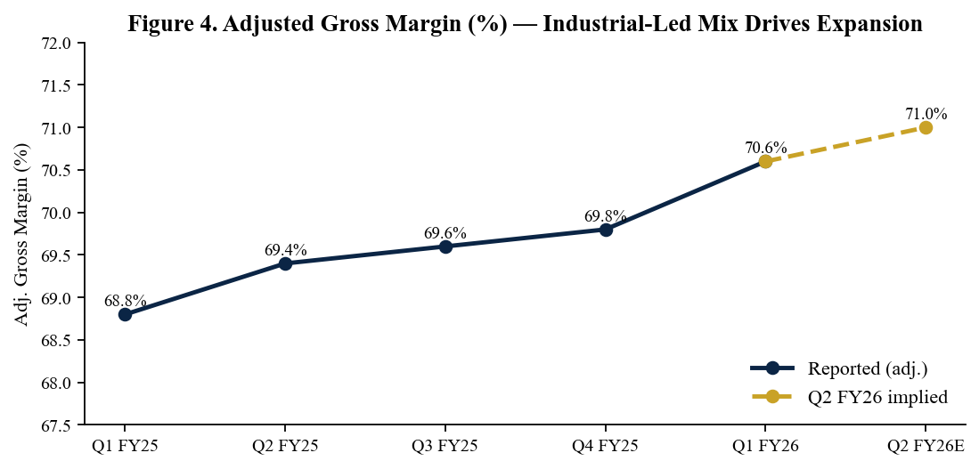
Figure 4. Adjusted gross margin — back through 70%, with utilization tailwinds intact.
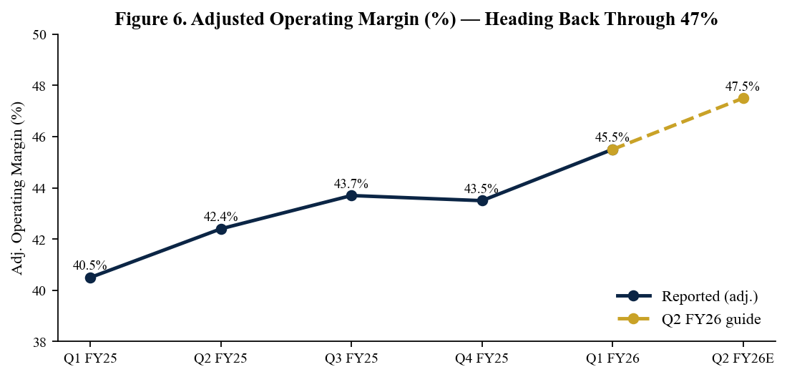
Figure 6. Adjusted operating margin — guided to 47.5% in Q2, near the company's long-term target band.
Q2 FY2026 Guidance vs. Street
Metric | Q2 FY26 Guide | Prior Street | Implied Variance
Revenue | $3.50B ±$100M | $3.23B | +8.4% ABOVE (mid)
Adjusted EPS | $2.88 ±$0.15 | $2.55 (est.) | +12.9% ABOVE
Adj. Operating Margin | 47.5% ±100 bps | ~46.0% | +150 bps above
Reported (GAAP) Op Margin | ~36.4% ±150 bps | — | Implied
Industrial (q/q) | +~20% | +~10% | ABOVE — broad reaccel
Communications (q/q) | + high-single | + low-single | ABOVE — AI infra
Automotive (q/q) | Flat to slightly down | + low-single | BELOW — seasonal
Consumer (q/q) | Down mid-single | Down low-single | BELOW — typical seasonality
FY 2026 Framework Commentary
Metric | Implied FY26 Path | Driver
Revenue | ~$13.5B (+23% y/y) | Industrial channel refill, comms AI ramp, auto recovery in 2H
Adjusted EPS | ~$11.00–11.50 | Operating leverage, gross-margin lift, lower share count
Adj. Gross Margin | ~71–72% exit | Mix, utilization, pricing
Adj. Operating Margin | ~47–48% exit | Opex flat to LSD growth on +20%+ revenue
Free Cash Flow | ~$5.5B (40% of rev) | Lower CapEx intensity (~15% to ~13% of revenue)
Capital Return Pace | >100% of FCF | 11% dividend hike + accelerated buyback execution
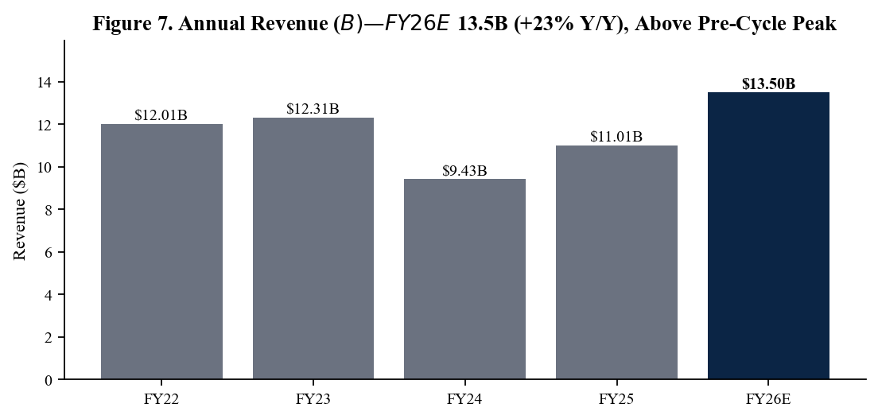
Figure 7. Annual revenue progression — implied FY26E ~$13.5B reclaims pre-cycle peak revenue.
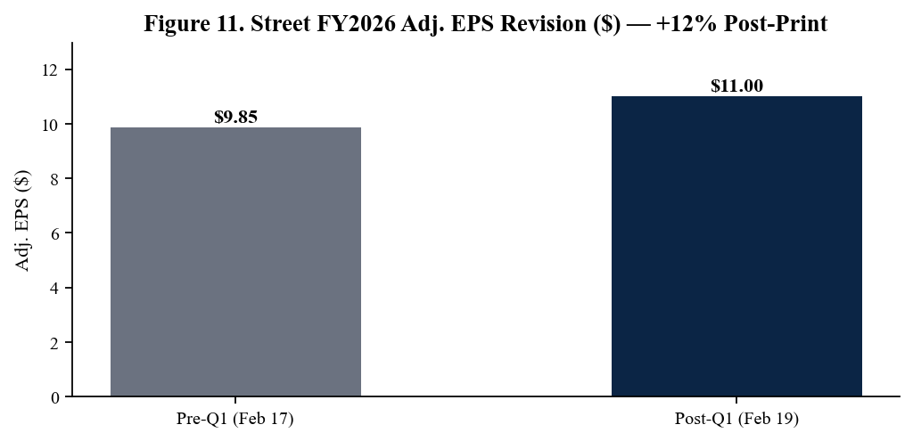
Figure 11. Sell-side FY26 EPS revision — Street revised EPS up ~12% post-print.

Updated Investment Thesis
What's Changed Since Q4 FY25
Three structural updates emerged from this print. First, the cyclical inflection across industrial — ADI's largest, highest-margin and most underestimated franchise — is now confirmed in numbers, not just commentary; +38% y/y growth with channel inventory still lean implies durable revenue compounding well into FY27. Second, communications has evolved from a recovery story into an AI-infrastructure growth story, with +63% y/y growth and management explicitly highlighting AI-related optical and wireline content. Third, operating leverage has resumed, with adjusted operating margin already at 45.5% and the Q2 guide implying 47.5% — within the company's long-term target band only two quarters into the recovery. Taken together, we lift our FY26 revenue estimate to $13.5B (from $12.5B), FY26 adjusted EPS to $11.20 (from $9.90), FY27 revenue to $14.8B (from $13.6B), and FY27 adjusted EPS to $13.50 (from $11.75).
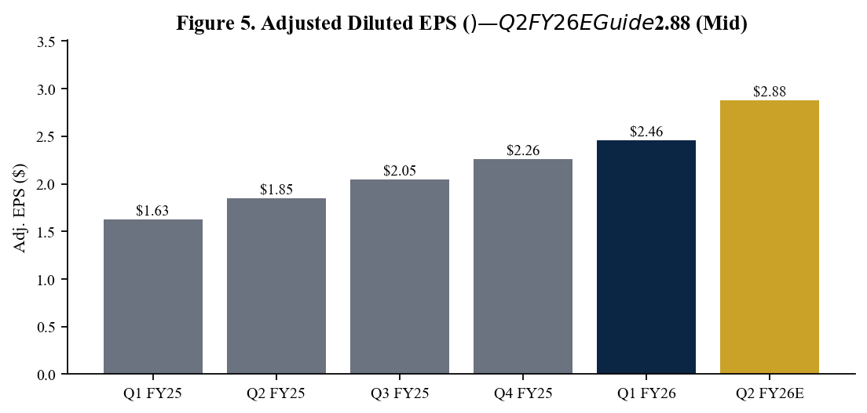
Figure 5. Adjusted EPS progression — Q2 FY26 guide of $2.88 (mid) implies +56% y/y.
Capital Return — 22nd Consecutive Dividend Hike, Buyback Pace Stepped Up
ADI returned approximately $1.09B to shareholders in Q1 FY26 ($545M dividends + $540M buybacks) — among the highest quarterly capital-return run-rates in company history. Management's 11% dividend raise to $1.10 per share marks the 22nd consecutive annual dividend increase and is a credible signal of confidence in the multi-year FCF trajectory. Buyback execution stepped up materially (to $540M from $415M sequentially), and management indicated capital return is expected to track in excess of 100% of FCF in FY26 as the company opportunistically deploys balance-sheet cash. With the company's TTM FCF margin at 39% and a path to ~$5.5B FY26 FCF on rising revenue, we model ~$5–6B of capital return per year over the FY26–FY28 window — implying total shareholder yield approaching 4% at current prices.
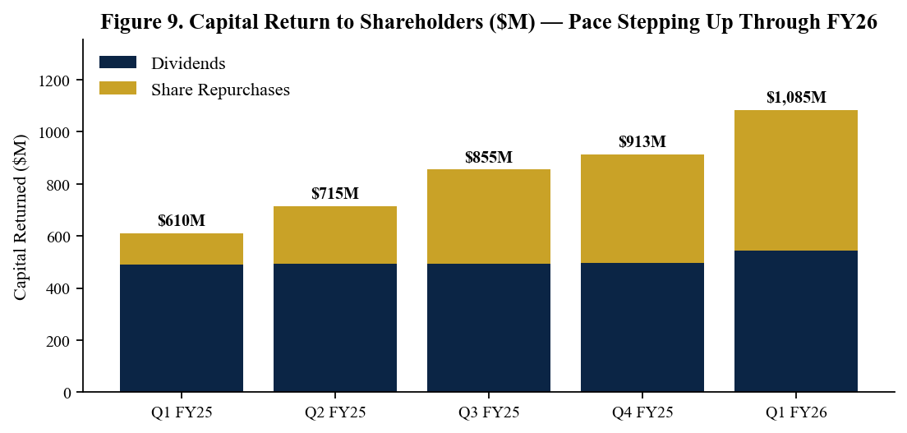
Figure 9. Quarterly capital return — buyback pace stepped up alongside the 11% dividend raise.
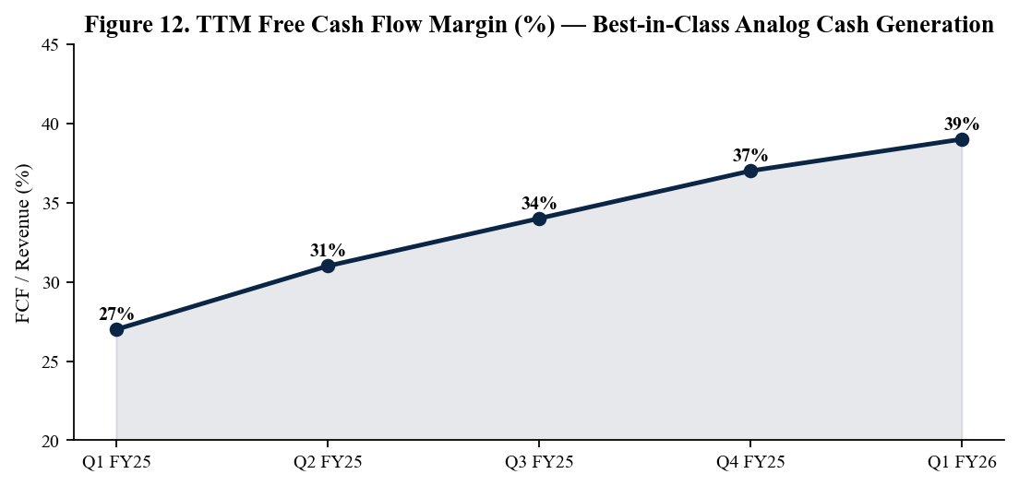
Figure 12. TTM FCF/revenue margin — 39% places ADI at the top of the analog peer group.
Valuation and Price Target
We raise our 12-month price target to $310 (from $260), based on 23x our revised FY27E adjusted EPS of $13.50. Our target multiple sits within ADI's 5-year forward-PE range of 20–28x and modestly below the current ~24x trailing multiple, reflecting our view that the premium-to-peers is justified given (i) the increased visibility on a multi-year industrial and AI-infra revenue compounding cycle, (ii) ADI's structurally higher gross-margin profile (~70%+) versus peer average (~55–60%), (iii) durable mid-30s FCF margins through the cycle, and (iv) capital-return capacity in excess of 100% of FCF on the prior year. Our DCF cross-check (8.5% WACC, 3% terminal growth, ~46% steady-state operating margin) yields an intrinsic fair value of $315, supportive of the multiples-based target. Bull case of $375 assumes industrial extends to a multi-year 8–10% revenue CAGR with sustained gross margins above 72%; bear case of $215 reflects an early-2027 industrial digestion cycle and renewed China weakness.
Scenario Analysis
Scenario | FY27 Adj. EPS ($) | Multiple | Implied Price
Bull — Industrial 9% CAGR, GM >72%, AI comms sustains | $15.00 | 25x | $375
Base — FY27 $14.8B revenue, 71% GM, 47% op margin | $13.50 | 23x | $310
Bear — Industrial digests in 2027, China cuts deeper | $11.50 | 19x | $215

Key Risks
- Industrial cycle reversal — although early in the recovery, a sharp second-derivative deceleration in industrial bookings (PMIs rolling over, capex pause) would compress the 2H FY26 setup and pressure operating leverage.
- Automotive softness extending — auto declined 8% q/q in Q1 and is guided 'flat to slightly down' in Q2; a longer trough on EV-platform pushouts in Asia would extend the segment drag into 2H FY26.
- China export controls / geopolitics — broader U.S. controls or retaliatory China demand cuts would compress the ~22% of revenue tied to China and disrupt distribution channels.
- Communications volatility — AI-infra demand has been a Q1 surprise driver; given the high q/q growth rate, the segment is exposed to lumpy hyperscaler purchasing patterns and order-pattern smoothing.
- Pricing concessions — extended industrial recovery may invite price renegotiations from large EMS and distribution partners; ADI has navigated this historically but it remains a gross-margin watch item.
- Valuation risk — ADI trades at a premium to broader semis and to its 5-year forward mean; a multiple compression event tied to a broader risk-off rotation would weigh on returns despite EPS growth.
Catalysts (Next 90 Days)
- ADI Q2 FY26 earnings — May 20, 2026; key watches are revenue versus the $3.50B guide mid, gross-margin sustainability above 70.5%, and any FY26 framework refinement.
- Industrial PMI prints (May/June) — confirmation that the global industrial demand recovery extends would directly support the FY26 framework and our revenue estimates.
- TI, ON, Microchip earnings reads — peer commentary on industrial and automotive demand throughout May will provide read-throughs to ADI's segment trajectory.
- Buyback execution disclosures — pace of share repurchases under the existing authorization provides a near-term tailwind to per-share metrics.
- AI infrastructure capex updates — hyperscaler quarterly results and capex commentary will calibrate the durability of communications-segment AI pull-through.
- Investor/analyst engagement — sell-side conferences (Bernstein late May, Bank of America June) historically provide medium-term framework refresh from ADI management.
Sources
- Analog Devices Q1 FY2026 Earnings Press Release — Investor Relations - https://investor.analog.com/news-releases/news-release-details/analog-devices-reports-fiscal-first-quarter-2026-financial
- Analog Devices Q1 FY2026 Press Release — analog.com Newsroom - https://www.analog.com/en/newsroom/press-releases/2026/2-18-2026-adi-reports-fiscal-1st-qtr-2026-financial-results.html
- Analog Devices Q1 FY2026 Press Release — PR Newswire - https://www.prnewswire.com/news-releases/analog-devices-reports-fiscal-first-quarter-2026-financial-results-302691090.html
- Analog Devices Form 8-K and 10-Q filings — SEC EDGAR - https://www.sec.gov/cgi-bin/browse-edgar?action=getcompany&CIK=0000006281&type=10-Q&dateb=&owner=include&count=40
- Analog Devices Q1 FY2026 Earnings Call Transcript — The Motley Fool - https://www.fool.com/earnings/call-transcripts/2026/02/18/analog-devices-adi-q1-2026-earnings-transcript/
- Analog Devices Q1 FY2026 Earnings Coverage — Yahoo Finance - https://finance.yahoo.com/news/analog-devices-surges-earnings-beat-124322283.html
- Analog Devices Q1 FY2026 Earnings Call Highlights — GuruFocus - https://www.gurufocus.com/news/8629115/analog-devices-inc-adi-q1-2026-earnings-call-highlights-strong-revenue-growth-and-dividend-increase
- Analog Devices Investor Relations — Financial Results Archive - https://investor.analog.com/financial-information/quarterly-results
- Analog Devices Q4 FY2025 Press Release (prior baseline) - https://www.analog.com/en/newsroom/press-releases/2025/11-25-2025-adi-reports-4th-qtr-fiscal-2025-financial-results.html
- Analog Devices Q1 FY2026 Earnings Coverage — Stocktitan - https://www.stocktitan.net/news/ADI/analog-devices-reports-fiscal-first-quarter-2026-financial-q2dgzds3s95y.html
Important Disclosures
This report was generated by an AI research assistant on May 2, 2026 and is intended for informational and educational purposes only. It is not a recommendation to buy or sell any security and should not be the sole basis for any investment decision. Figures are sourced from primary public filings (Form 8-K, earnings release, transcript, IR materials) and should be independently verified. Past performance is not indicative of future results.

