Applied Materials, Inc. (NASDAQ: AMAT)
Equity Research — Earnings Update | Semiconductor Capital Equipment
Q1 FY2026 Earnings Update
Reported February 12, 2026 | Quarter ended January 25, 2026 | As of May 2, 2026
Rating: BUY Price Target: $450 (raised from $400)
Investment Summary
Applied Materials delivered a clean Q1 FY2026 print headlined by record DRAM equipment revenue, record Applied Global Services (AGS) revenue, and the highest non-GAAP gross margin in 25 years (49.1%). Net revenue of $7.01B topped the $6.85B guide midpoint and consensus of $6.88B, while non-GAAP EPS of $2.38 cleared the $2.21 consensus by ~8%. More importantly, management reiterated that the wafer fab equipment (WFE) market is set to grow more than 20% in calendar 2026, anchored by leading-edge logic, HBM and advanced packaging — all directly tied to AI compute. Q2 FY26 guidance of $7.65B / $2.64 EPS embeds ~9% sequential revenue growth and would mark a record quarter for the company. With China revenue normalizing to a low-20s mix and AI-driven demand more than offsetting export-control attrition, we view AMAT as a primary beneficiary of the current capex super-cycle and raise our 12-month price target to $450 (from $400), implying modest upside on raised CY27E EPS power of $11.00.
Key Takeaways
- Net revenue of $7.01B (-2% y/y, but at the high end of guide of $6.85B ±$400M); non-GAAP EPS of $2.38 vs. $2.21 consensus (+8%).
- Non-GAAP gross margin of 49.1% — highest in 25 years — driven by mix, pricing discipline and AGS growth.
- Semiconductor Systems revenue $5.14B with record DRAM contribution (34% of segment, up from 25% in Q1 FY25) supporting HBM build-outs.
- Applied Global Services hit a record $1.56B (+1.5% y/y) with 28.1% non-GAAP operating margin — recurring base now ~22% of total revenue.
- Q2 FY26 guide: revenue $7.65B ±$500M (+9% q/q at mid), non-GAAP EPS $2.64 ±$0.20, gross margin ~49.3% — would be a record quarter.
- China revenue 27% of combined Semi+AGS (down from 36% peak); $252.5M export-control compliance accrual partially offsets margin tailwind.
- Capital return: $702M in Q1 ($337M buybacks + $365M dividends); 15% dividend hike to $0.53/qtr and new $10B repurchase authorization in March 2026.
- We raise BUY-rated PT to $450 (from $400) — 41x our raised CY27E non-GAAP EPS of $11.00, in line with semicap peer multiples and AMAT's 5-yr mean.

Q1 FY26 Results Snapshot
Metric | Actual | Consensus / Guide | Beat / Miss
Net Revenue | $7.01B | $6.88B (cons) / $6.85B (guide) | +1.9% BEAT
Non-GAAP Diluted EPS | $2.38 | $2.21 | +7.7% BEAT
GAAP Diluted EPS | $2.54 | — | +75% y/y
Non-GAAP Gross Margin | 49.1% | 48.5% | +60 bps BEAT (highest in 25 yrs)
GAAP Operating Income | $1.83B (26.1%) | — | Above plan
Cash from Operations | $1.69B | — | FCF $1.04B
Capital Return | $702M | — | $337M buyback + $365M div

Detailed Results
Applied Materials' Q1 FY26 print was fundamentally about mix and durability rather than headline growth. Total revenue of $7.01B was down 2% year-over-year on a tough Q1 FY25 compare ($7.17B), but came in at the high end of the $6.85B ±$400M guide and roughly $130M above consensus. The more important story was the quality of the gross margin: at 49.1% non-GAAP — the highest the company has reported in 25 years — Applied is now operating well above its multi-year 47% structural average, reflecting the cumulative impact of pricing actions, mix toward more value-added 200mm and gate-all-around tools, and a structurally higher AGS contribution. Non-GAAP EPS of $2.38 was flat year-over-year despite the modest revenue decline — gross-margin expansion fully absorbed the topline pressure and a slightly higher tax rate.
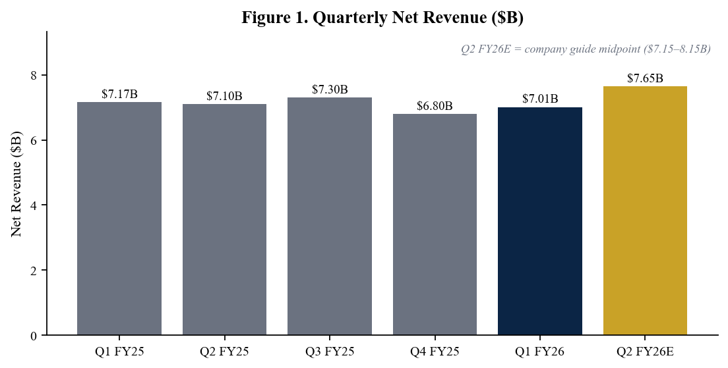
Figure 1. Quarterly net revenue — Q2 FY26E reflects the midpoint of company guidance ($7.15–8.15B).
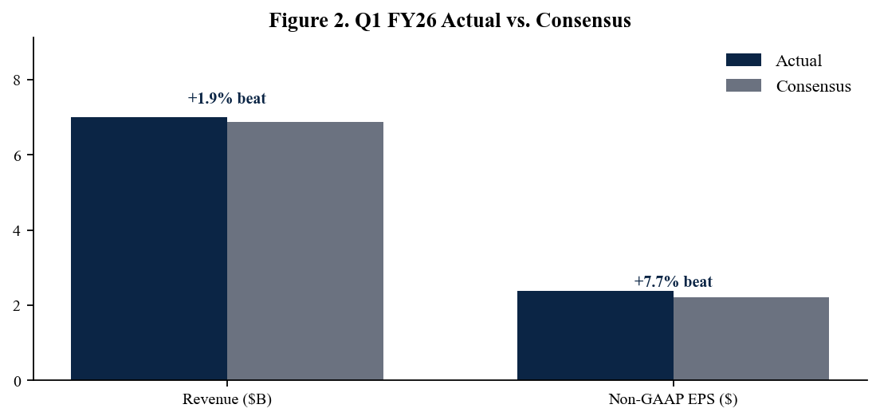
Figure 2. Q1 FY26 actuals vs. sell-side consensus — solid revenue beat with above-guide margin.
Segment Detail — Record DRAM and Record Services
Semiconductor Systems revenue of $5.14B was down 4% year-over-year but mix-rich: foundry/logic/other contributed 62% (down from 70% in Q1 FY25), while DRAM jumped to 34% (up from 25%) on Samsung and SK hynix capacity additions for HBM3e and HBM4. NAND remained subdued at just 4% of the segment. Management called Q1 a record quarter for DRAM equipment revenue and pointed to continued HBM-driven incremental investment through CY27. Applied Global Services delivered a record $1.56B (+1.5% y/y) at 28.1% non-GAAP operating margin — the recurring services and spares base is now structurally over $6B annualized and provides important earnings stability across the WFE cycle. Display revenue, included in 'Other,' was $312M, supported by IT-OLED tool shipments to Korean panel makers.
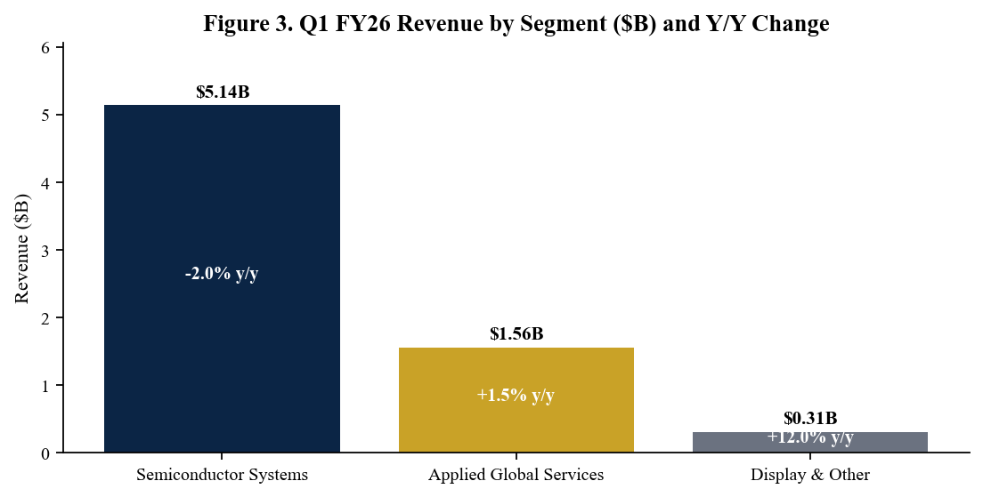
Figure 3. Q1 FY26 revenue by segment — Semiconductor Systems still ~73% of total, AGS at record 22%.
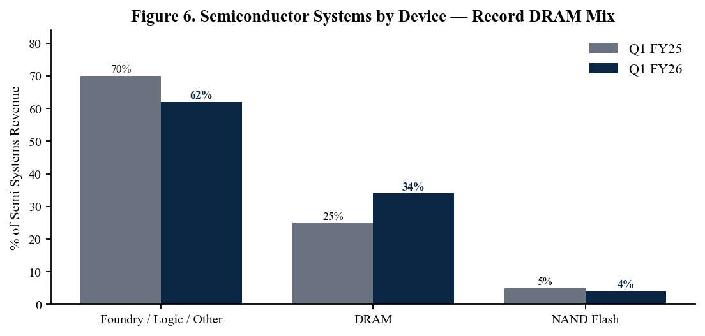
Figure 6. Semi Systems device mix — DRAM stepped up to 34% from 25% on HBM-driven memory capex.
Geographic Mix — China Normalization, Korea Acceleration
Geographic concentration shifted meaningfully in Q1 FY26. China declined to 27% of combined Semiconductor Systems + AGS revenue (from a 36% peak in CY24 and 29% in Q1 FY25) as the cumulative effect of expanded U.S. export controls reduced advanced-node tool eligibility for Chinese memory and logic customers. The shortfall has been more than absorbed by accelerating demand from Korea (21% of revenue, up from 17%) and a steady contribution from Taiwan (16%) and the U.S. (14%, supported by Intel and Micron domestic capacity ramps). Importantly, AMAT recorded a $252.5M accrual related to an export-controls compliance matter — a one-time GAAP item that we expect to remain non-recurring but will continue to monitor through subsequent disclosures.
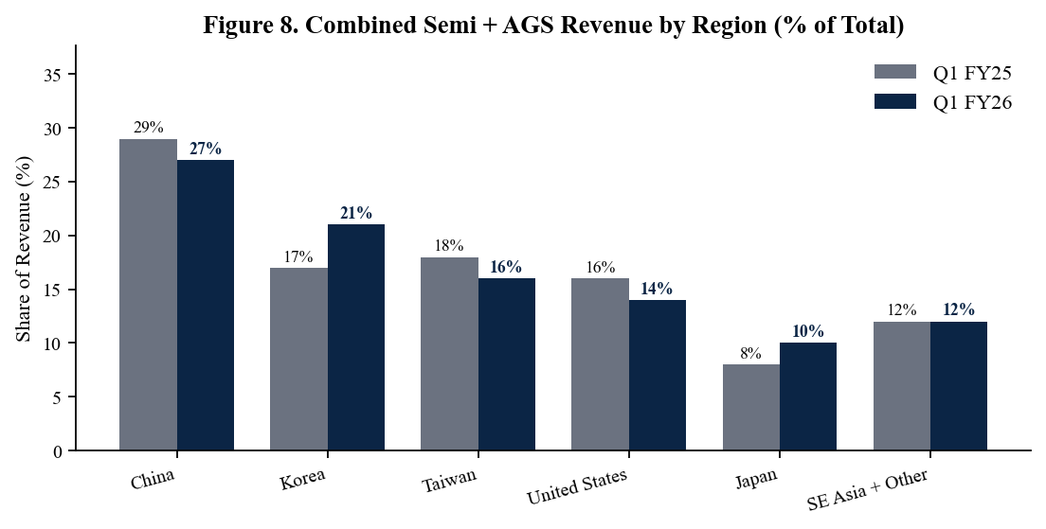
Figure 8. Combined Semi + AGS revenue by region — China share normalizing to mid-20s as Korea ramps.

Margins, Guidance and the FY26 Setup
Q1 FY26 non-GAAP gross margin of 49.1% is a structural milestone — the highest reported in 25 years — and reflects the benefits of mix (DRAM, AGS, gate-all-around), pricing discipline and the continuing growth of the more profitable installed base business. Q2 FY26 guidance of approximately 49.3% gross margin extends the trajectory and signals that margin improvement is not a one-quarter print. Management's Q2 FY26 guide of $7.65B revenue and $2.64 non-GAAP EPS would represent a sequential acceleration of approximately 9% and would mark the first $7.5B+ quarter in company history at the midpoint. Combined with the framework comment that wafer fab equipment will grow more than 20% in calendar 2026, the implied second-half FY26 setup is considerably stronger than consensus had modeled going into the print.
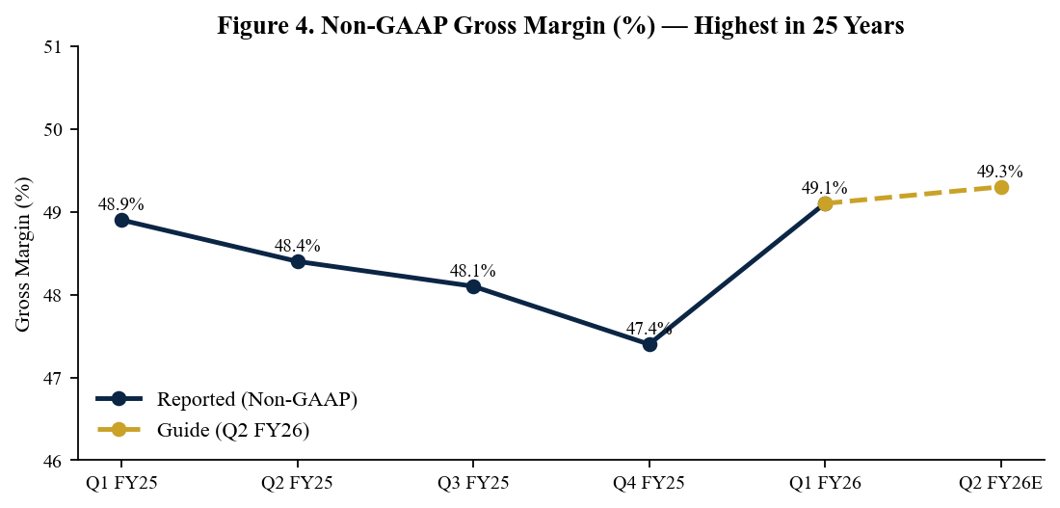
Figure 4. Non-GAAP gross margin trajectory — Q2 FY26 guide of ~49.3% extends 25-year record.
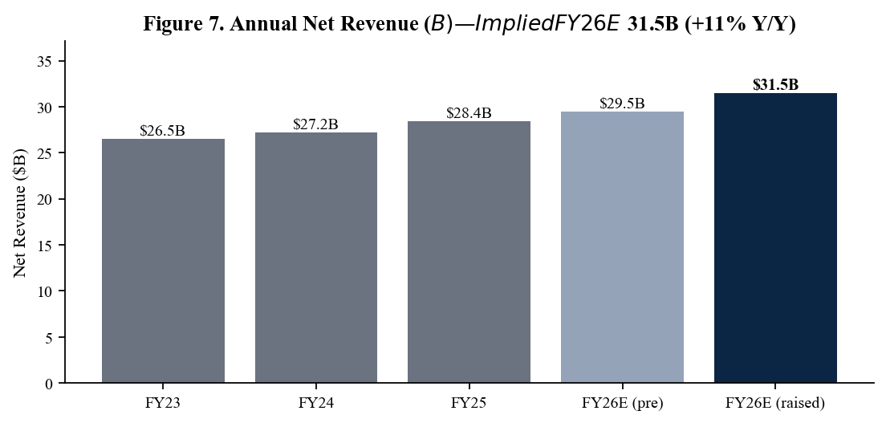
Figure 7. Annual revenue progression — implied FY26E ~$31.5B reflects 20%+ WFE growth commentary.
Q2 FY2026 Guidance vs. Street
Metric | Q2 FY26 Guide | Prior Street | Implied Variance
Net Revenue | $7.65B ±$500M | $7.40B | +3.4% above (mid)
Non-GAAP EPS | $2.64 ±$0.20 | $2.50 | +5.6% above
Non-GAAP Gross Margin | ~49.3% | 48.7% | +60 bps above
Operating Expenses | ~$1.415B | $1.43B | Slightly favorable
Effective Tax Rate | ~11% | 12% | Favorable
FY 2026 Framework Commentary
Metric | Implied FY26 Path | Driver
WFE Market Growth | >20% y/y in CY26 | Leading-edge logic, HBM, advanced packaging
AMAT Revenue (implied) | ~$31.5B (+11% y/y) | Above-trend semi, record AGS
Gross Margin | 49–50% range | Mix, pricing, AGS leverage
China Mix | Low-to-mid 20s% | Normalizing post-export controls
Capital Return Rate | ~80–90% of FCF | $10B new buyback authorization

Updated Investment Thesis
What's Changed Since Q4 FY25
Three things have changed structurally with this print. First, gross-margin durability is now evident: with Q1 at 49.1% and Q2 guided to 49.3%, AMAT is operating at a structural premium to the 47% multi-year average and we now model FY26 GM at 49.5% (vs. 48.5% prior). Second, the DRAM mix step-up to 34% of Semiconductor Systems (from 25% a year ago) confirms that HBM is no longer a tactical add-on — it is becoming a primary capacity driver and meaningfully elevates AMAT's exposure to AI inference economics. Third, management's explicit guidance that WFE will exceed 20% growth in CY26 puts a quantitative anchor under the second-half setup; we lift FY26 revenue to $31.5B and FY27 to $34.0B, with FY27E non-GAAP EPS of $11.00 (vs. $9.60 prior).
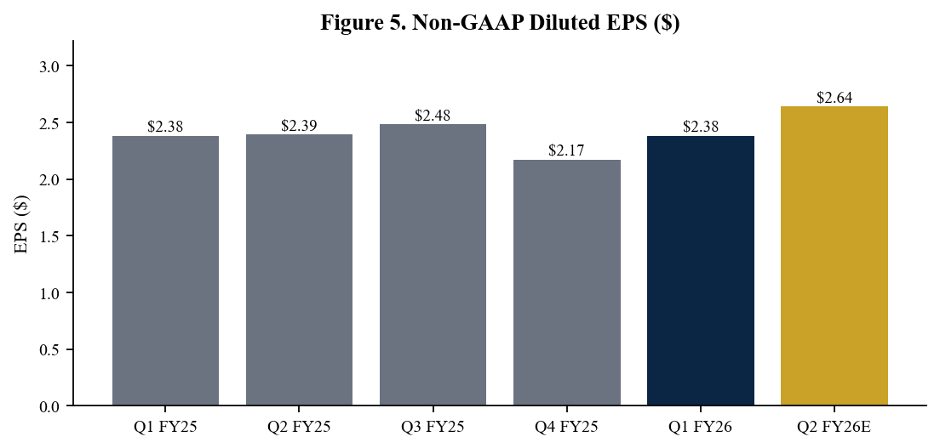
Figure 5. Non-GAAP EPS — Q2 FY26 guide of $2.64 would mark a record quarter.
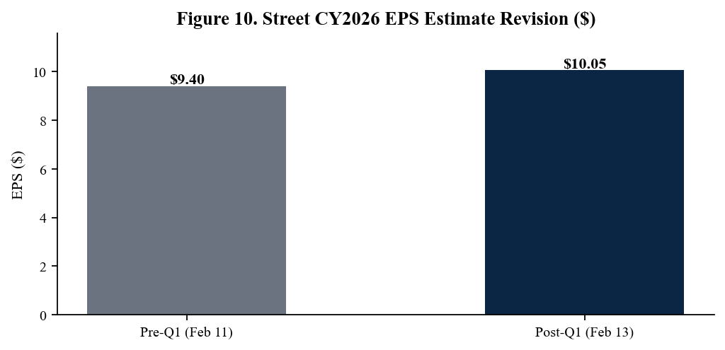
Figure 10. Sell-side CY26 EPS revision — consensus moved up ~7% post-print.
Capital Return — Buyback Step-Down Was Optical, Not Structural
AMAT returned $702M to shareholders in Q1 FY26 ($365M dividends + $337M buybacks), a notable step-down from the $1.4–1.9B quarterly pace observed throughout FY25. Management explicitly attributed the moderation to (i) blackout windows around the export-controls accrual and (ii) timing of the new $10B repurchase authorization, which the Board approved in March 2026. We model buybacks accelerating back to a $1.2–1.5B quarterly pace by Q3 FY26. The 15% dividend raise to $0.53/share (effective June 11, 2026) is a credible signal of management confidence in the FCF trajectory — the new annualized $2.12 dividend implies a ~0.5% yield at current prices and continues a 7-year double-digit-CAGR pattern.
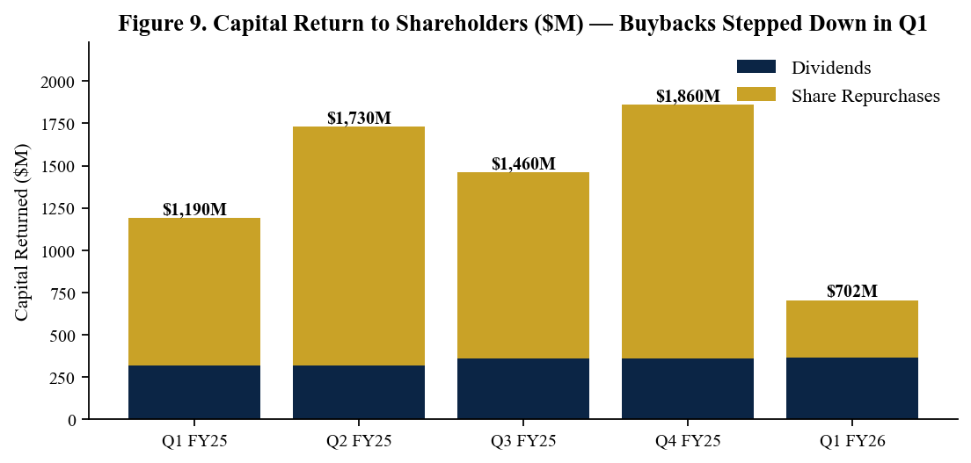
Figure 9. Quarterly capital return — buyback step-down in Q1 attributed to timing, not strategic shift.
Valuation and Price Target
We raise our 12-month price target to $450 (from $400), based on 41x our revised CY27E non-GAAP EPS of $11.00. Our target multiple sits at AMAT's 5-year forward-PE average, which we view as appropriate given (i) durable mid-teens FCF growth, (ii) ~85–90% of FCF returned to shareholders, and (iii) AMAT's structural exposure to AI-driven WFE growth. Our DCF cross-check (8.5% WACC, 3% terminal growth, ~30% steady-state operating margin) yields an intrinsic fair value of $462, supporting our multiples-based target. Our bull case of $540 assumes WFE compounds at 18% through CY27 with sustained 50% gross margins, while the bear case of $310 reflects a deeper China cut and 2027 logic capex digestion.
Scenario Analysis
Scenario | CY27 EPS ($) | Multiple | Implied Price
Bull — WFE +18% CAGR, 50% GM, China stable | $12.50 | 43x | $540
Base — FY27 $34B revenue, 49.5% GM, $10B buyback | $11.00 | 41x | $450
Bear — Export controls escalate, capex digestion | $8.85 | 35x | $310

Key Risks
- Export-control escalation — further U.S. restrictions on advanced 200mm or memory tools to China could compress mix below 20% and trigger additional one-time accruals.
- WFE cyclicality — semicap is historically a cyclical industry; a hyperscaler capex pause in late CY26 could compress 2027 wafer-add intentions across foundry and memory.
- Memory volatility — DRAM is now 34% of Semi Systems segment; an HBM pricing/oversupply event would reverse the mix tailwind and pressure 2H26 gross margin.
- Customer concentration — TSMC, Samsung and SK hynix together represent the bulk of leading-edge orders; any single customer pause is material.
- Competitive intensity — Lam Research and Tokyo Electron compete directly in etch/deposition; ASML occupies the litho monopoly. Share shifts at advanced nodes warrant ongoing scrutiny.
- Tariff / FX — additional tariffs or USD strength reduce reported earnings translation and could pressure customer capex budgets internationally.
Catalysts (Next 90 Days)
- Q2 FY26 earnings release — May 14, 2026; key watch items are revenue versus the $7.65B midpoint, gross-margin sustainability and the magnitude of buyback re-acceleration.
- Investor Day — historically held in spring; potential update on long-term financial model and gate-all-around / advanced packaging revenue contribution.
- Industry data — May/June SEMI WFE forecast updates and SEMICON West announcements provide direct read-throughs for AMAT's CY26 framework.
- Customer commentary — TSMC and Samsung mid-July earnings will refine CY26 capex magnitude; a TSMC capex raise above $52B would directly support our model.
- Memory pricing — DRAM contract pricing trends (TrendForce, DRAMeXchange) will signal whether HBM-driven capex sustainability holds into 2H FY26.
- Capital return — initial cadence under the new $10B buyback authorization (announced March 2026) and the June 11 dividend payment.
Sources
- Applied Materials Q1 FY2026 Earnings Press Release — Investor Relations - https://ir.appliedmaterials.com/news-releases/news-release-details/applied-materials-announces-first-quarter-2026-results/
- Applied Materials Form 8-K Q1 FY2026 — SEC EDGAR - https://www.sec.gov/cgi-bin/browse-edgar?action=getcompany&CIK=0000006951&type=8-K&dateb=&owner=include&count=40
- Applied Materials Q1 FY2026 Earnings Call Transcript — Investing.com - https://www.investing.com/news/transcripts/earnings-call-transcript-applied-materials-q1-2026-beats-eps-forecast-stock-slips-93CH-4504178
- Applied Materials Q1 FY2026 Earnings Highlights — Yahoo Finance - https://finance.yahoo.com/news/applied-materials-inc-amat-q1-050436200.html
- Applied Materials Quarterly Earnings Archive — IR - https://ir.appliedmaterials.com/financial-information/quarterly-results/
- Applied Materials Q4 FY2025 / Full-Year 2025 Results - https://ir.appliedmaterials.com/news-releases/news-release-details/applied-materials-announces-fourth-quarter-and-fiscal-year-2025
- Applied Materials Investor Relations Home - https://ir.appliedmaterials.com/
- Applied Materials FCF Analysis — 24/7 Wall St (March 2026) - https://247wallst.com/investing/2026/03/10/applied-materials-q1-2026-free-cash-flow-hit-1-04-billion-so-why-is-the-stock-sliding/
- Manufacturing Dive — AMAT Q1 FY2026 / 20% WFE growth commentary - https://www.manufacturingdive.com/news/applied-materials-reports-7b-q1-2026-revenue/812715/
Important Disclosures
This report was generated by an AI research assistant on May 2, 2026 and is intended for informational and educational purposes only. It is not a recommendation to buy or sell any security and should not be the sole basis for any investment decision. Figures are sourced from primary public filings (Form 8-K, earnings release, transcript, IR materials) and should be independently verified. Past performance is not indicative of future results.

