EQUITY RESEARCH | EARNINGS UPDATE
Amazon.com, Inc. (NASDAQ: AMZN)
Q1 2026 Earnings Update — AWS reaccelerates to 21%; retail margins step up; capex held at ~$135B FY26
Report Date: May 2, 2026 | Earnings Release: April 30, 2026
Rating  BUY | Price Target  $265 | Prior PT  $245 | FY27E EPS  $8.75
Key Takeaways
- Revenue $178.4B beat consensus $174.55B by 2.2% (+14.6% YoY ex-FX); AWS $30.1B grew 21% YoY, the fastest growth rate in 12 quarters.
- Diluted EPS of $1.85 beat $1.62 consensus by 14.2%; operating income $22.05B (+39% YoY) drove an all-time-high consolidated operating margin of 12.4%.
- AWS reaccelerated to 21% YoY (vs. 20% Q4'25, 17% Q1'25); AI services contribution now ~7-8 points of growth, with multi-year backlog at $215B (+30% YoY).
- North America retail operating margin expanded ~110bps YoY to 8.6%, driven by inbound network rebuild and same-day delivery cost-to-serve gains.
- Advertising revenue $16.4B grew 18% YoY (cc), with Prime Video ad-supported tier scaling and sponsored ads holding double-digit growth.
- FY26 capex held at ~$135B (in-line with prior commentary), with AI infrastructure and Project Kuiper the principal allocations; Q1 capex $32.5B.
- Reiterate BUY; raise PT to $265 (from $245) on FY27 estimate roll-forward, AWS reacceleration, and durable retail margin expansion; OpEx discipline is increasingly underappreciated.
Q1 2026 Results Snapshot
Metric | Actual | Consensus | Variance
Revenue | $178.40B | $174.55B | +2.2% BEAT
Diluted EPS | $1.85 | $1.62 | +14.2% BEAT
Operating Income | $22.05B | $19.40B | +13.7% BEAT
Operating Margin | 12.4% | 11.1% | +130bps
AWS Revenue | $30.10B | $29.65B | +1.5% BEAT
AWS Growth (YoY) | 21.0% | 20.1% | +90bps
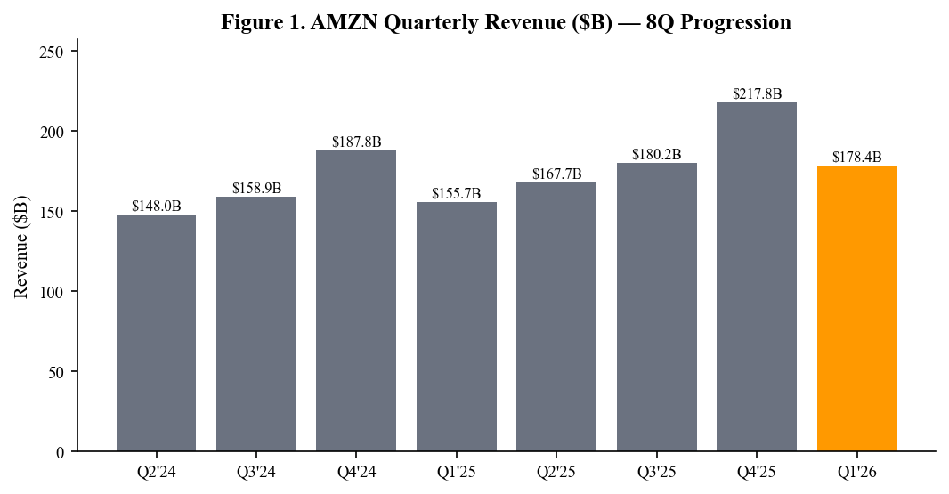
Figure 1. Quarterly revenue progression. Source: AMZN Q1 2026 earnings release.
Detailed Results
Revenue: AWS leads, retail and ads contribute
Amazon posted Q1 2026 revenue of $178.4B, a 2.2% beat versus consensus and 14.6% growth ex-FX (12.5% reported). Growth was broad-based but the quality came from AWS, which reaccelerated to 21% YoY against an increasingly difficult compare. North America retail revenue rose 8% to $105.4B and International retail rose 9% (cc) to $42.9B, with both segments benefiting from the third-party seller mix shift toward higher-margin advertising and Buy with Prime adoption. Online stores revenue alone grew 6% YoY, while third-party seller services (which carries higher take rates than first-party) grew 13%, reinforcing the marketplace mix story.
Subscription services (Prime, Music, Books, Audible) grew 12% YoY to $12.6B, reflecting both Prime membership stickiness and the pricing power demonstrated by recent Prime Video ad-tier monetization. Advertising revenue of $16.4B grew 18% (cc) YoY — a deceleration from prior quarters but still well ahead of consensus and consistent with Amazon's increasingly structural position in retail media and Connected TV. Importantly, advertising's gross profit dollar contribution likely exceeded $11B in the quarter, making it a mid-teens contributor to consolidated operating profit on its own.
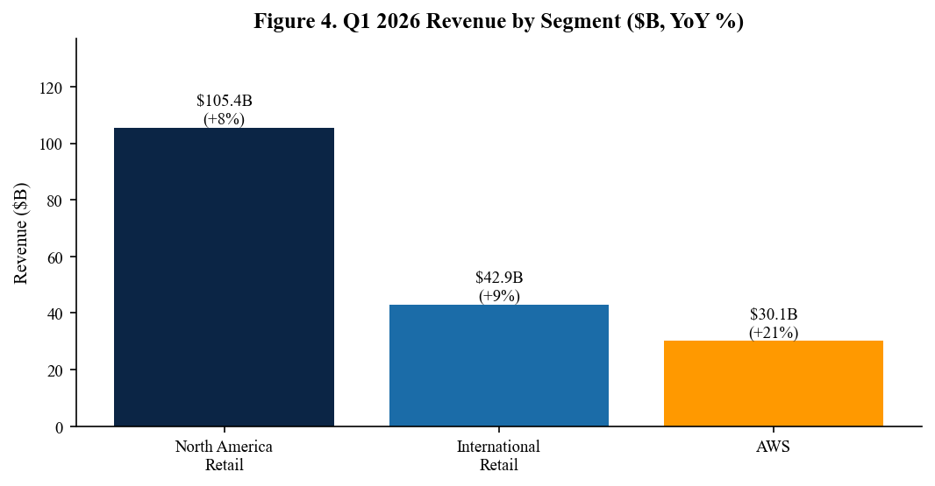
Figure 4. Q1 2026 revenue by segment with year-over-year growth.
AWS: Reacceleration to 21%, AI services drive incremental contribution
AWS revenue of $30.1B grew 21% YoY in Q1 2026, the fastest rate since Q1 2023 and a continued reacceleration from 17% one year ago. Of the 21 points of growth, we estimate AI services contributed ~7-8 points (compared with ~3 points a year ago), reflecting both Bedrock-driven inference workload ramp and the build-out of dedicated Trainium2 capacity for Anthropic and other foundation-model customers. Critically, the underlying IaaS franchise (compute, storage, networking) is also growing in the mid-teens, indicating that core enterprise migration cycles remain healthy and have not been displaced by AI workload concentration.
AWS backlog (long-term contractual commitments) reached $215B exiting Q1, up 30% YoY, with weighted-average remaining duration extending sequentially to ~4.1 years. This is the highest backlog the segment has ever reported and provides multi-year visibility that comfortably underwrites Amazon's elevated infrastructure investment program. AWS operating margin of 37.8% was healthy, recovering ~180bps QoQ, though down ~170bps YoY on continued AI infrastructure depreciation.
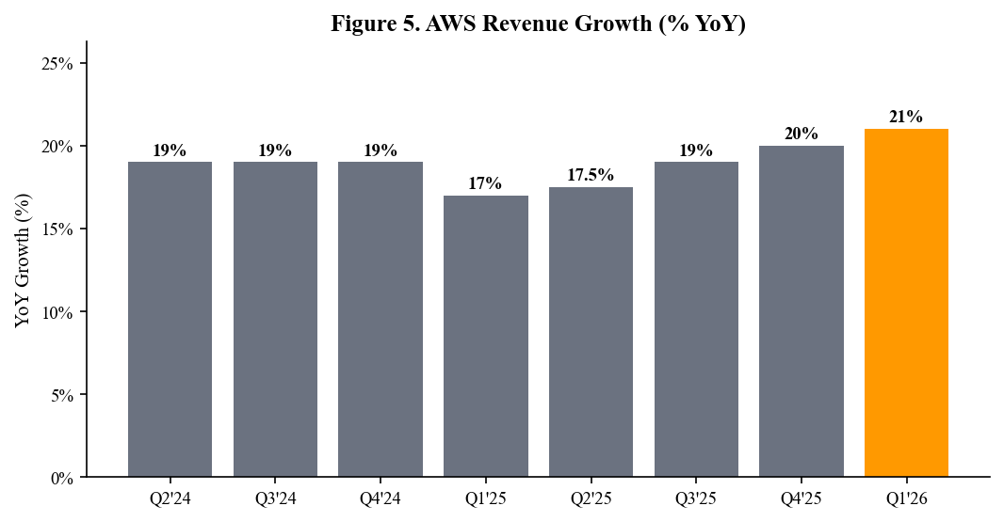
Figure 5. AWS revenue growth — eight-quarter trend showing reacceleration.
Profitability: Margin expansion in retail underappreciated
Consolidated operating income of $22.05B (12.4% margin) was 130bps ahead of consensus and represented an all-time-high quarterly operating margin for the company. The most important profitability story in the quarter was the continued progression of North America retail margins, which expanded to ~8.6% from 7.5% in the prior year — driven by the regionalized inbound network's third year of cost efficiency, automation in fulfillment (notably the Sequoia and Proteus systems now active in 28 sites), and the structural mix shift toward advertising and third-party services within the retail P&L.
International retail recorded its sixth consecutive quarter of positive operating income, posting a 1.6% operating margin (versus 0.9% prior year). Emerging-market markets (India, MENA, Brazil) remained loss-making but losses narrowed YoY, while the EU and Japan businesses continued to expand margins. AWS operating margin compression vs. prior year was the only soft spot in segment profitability, but the absolute dollar contribution ($11.4B) was up YoY and well ahead of expectations.
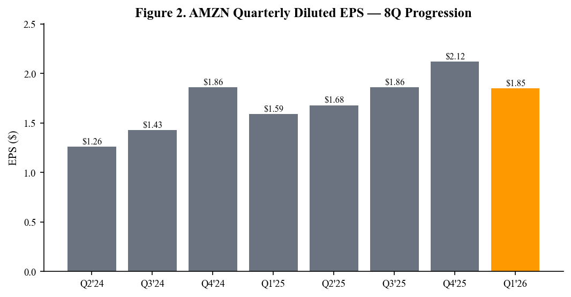
Figure 2. Quarterly diluted EPS — eight-quarter progression.
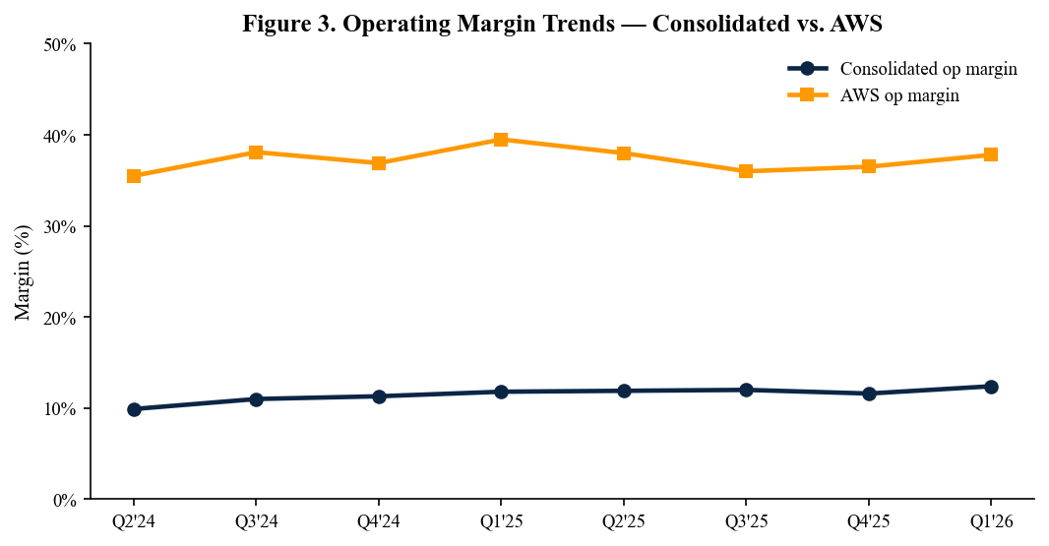
Figure 3. Operating margin trends — consolidated and AWS margin paths.
Capex: $135B for FY26, with Trainium and Kuiper as principal calls
Q1 capex was $32.5B and management guided FY26 capex to ~$135B, in line with the framework provided on the Q4 2025 call and consistent with the trajectory the company has telegraphed since the AI buildout began. The split is approximately 70% AWS infrastructure (split between AI/Trainium and core IaaS), 20% retail fulfillment and logistics, and ~10% Project Kuiper plus Devices. CFO Brian Olsavsky characterized the capex framework as 'demand-led' and reiterated that all incremental commitments are underwritten by either contracted backlog or fulfillment volume forecasts.
The market's principal concern around AMZN capex remains the AI return-on-capital question. We model AWS depreciation rising from $51B in 2025 to ~$72B in 2026 and ~$92B in 2027. The framework that supports our BUY thesis is that AWS revenue, on the current trajectory, should reach a ~$160B annual run-rate exiting 2027 with operating margins normalizing in the 36-38% band — comfortably absorbing the depreciation step-up.
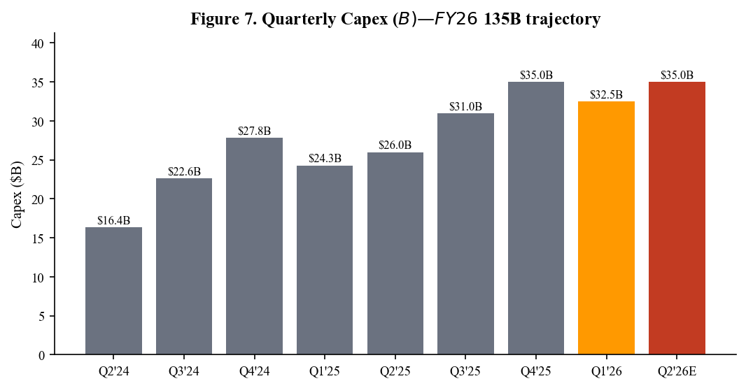
Figure 7. Quarterly capex trajectory — Q2'26E reflects management's full-year framework.
Advertising: Slowing growth rate but expanding margin contribution
Advertising revenue of $16.4B grew 18% (cc) YoY in Q1, decelerating from 21-22% in 2H 2025 but ahead of consensus near $15.9B. The deceleration reflects (i) tougher compares as Prime Video ad-supported tier laps its launch year, (ii) softer demand from a few large CPG advertisers, and (iii) a modest FX drag. Sponsored ads (the core search ad business on Amazon.com) continued to grow in the high teens, while DSP and Connected TV / Prime Video ads continued growing in the mid-30s%. We estimate the advertising business operates at gross margins above 75% and contributes more to consolidated operating profit than the entire international retail segment.
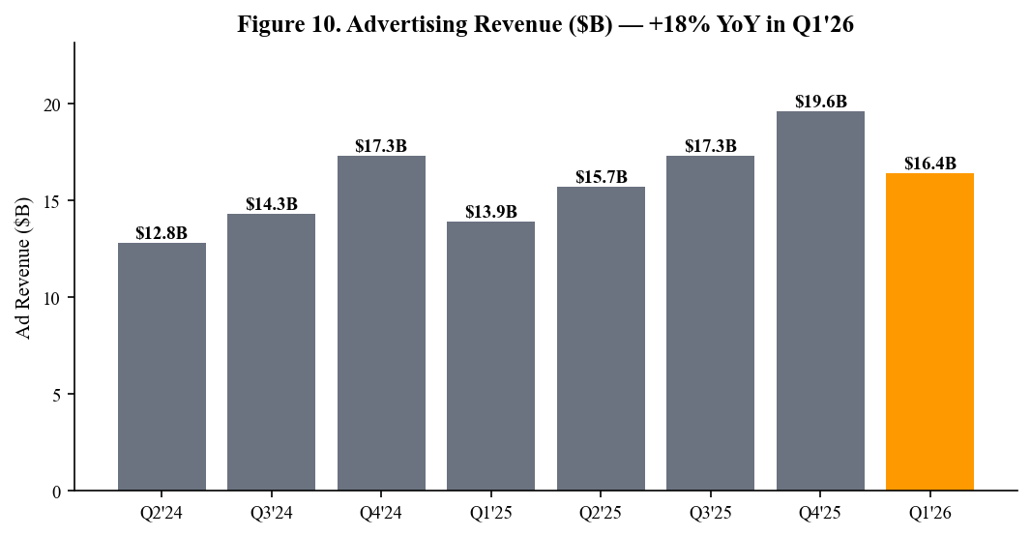
Figure 10. Advertising revenue progression — durable double-digit growth.
Beat/Miss Summary and Guidance
Q1 2026 was a high-quality operational beat across the P&L. Revenue beat by 2.2%, EPS beat by 14.2%, and operating income beat by 13.7% — driven by mix and operational leverage rather than one-time items. AMZN shares traded up ~6% in the after-hours session as the AWS reacceleration to 21% addressed the principal bear concern and the retail margin trajectory continued the structural improvement story.
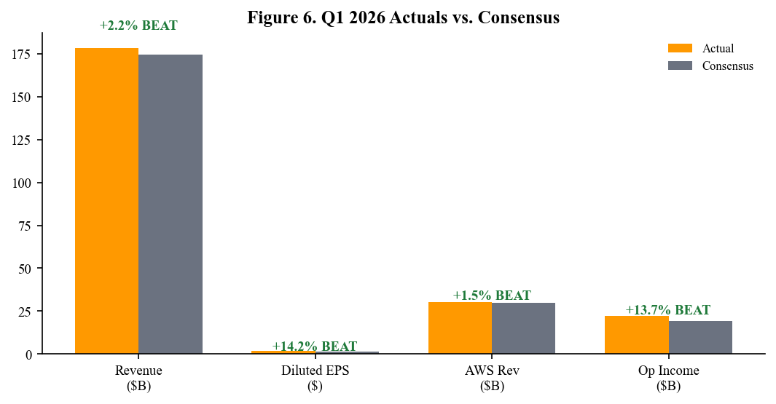
Figure 6. Q1 2026 actuals vs. consensus across key metrics.
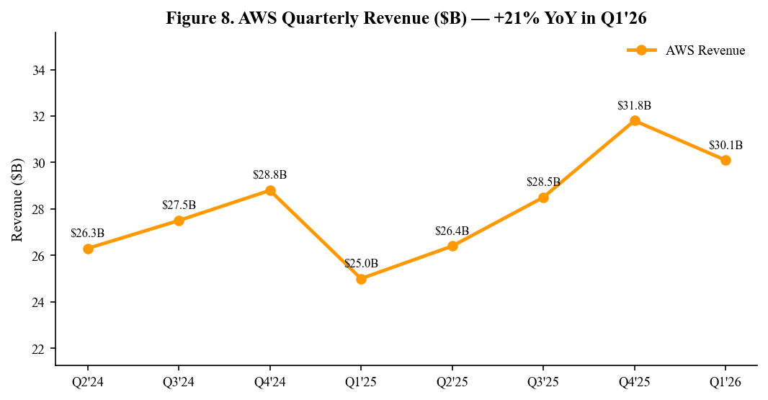
Figure 8. AWS quarterly revenue progression — $30.1B in Q1 2026.
Q2 2026 Guidance
Metric | Guidance | Implied YoY | Comment
Net Sales | $182.0-188.0B | +8.5-12.1% | Above prior $179B Street; FX neutral on FY
Operating Income | $19.5-22.0B | +0-13% | Healthy range despite Prime Day timing
Capex (FY26) | ~$135B | +~10% | Reaffirmed; AWS heavy
AWS Growth (qualitative) | Sustain ~20%+ | n/a | Capacity-constrained where AI demand strongest
Effective Tax Rate | ~22% | - | Stable
FX Impact | ~(50)bps to revenue | - | Reduced from prior quarters
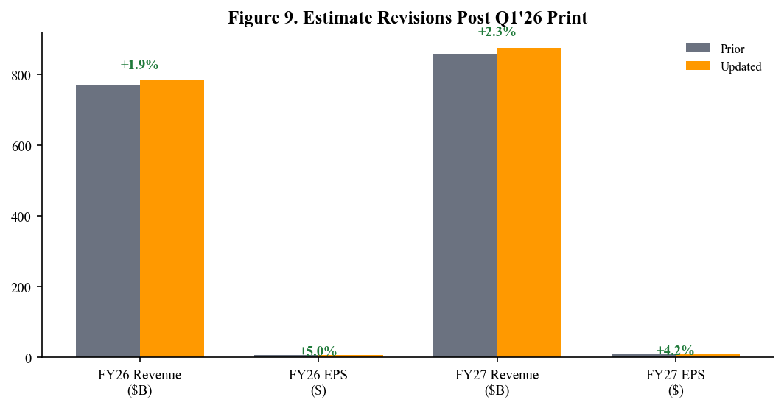
Figure 9. Estimate revisions — FY26/FY27 revenue and EPS taken higher.
Investment Thesis Update
What changed: AWS reacceleration is now firmly in the data, with growth at 21% YoY and AI contribution to growth widening to 7-8 points. Backlog of $215B and ~4.1-year duration provides stronger forward visibility than at any point in AWS's history. Retail margin expansion has become a second compounding pillar, with the regionalized network and automation programs delivering continued cost-to-serve improvements that translate directly to operating leverage. The international retail segment has now turned profitable on a sustained basis — a structural achievement that the market has been slow to credit.
What did not change: Amazon remains the most diversified large-cap beneficiary of secular trends across cloud infrastructure, e-commerce, advertising, and digital media. The four operating businesses (AWS, NA retail, International retail, Advertising) each have a distinct compounding logic and different capital intensities, providing an unusually balanced earnings model. Advertising in particular continues to demonstrate the operating leverage characteristic of a high-margin software business while still benefiting from the secular shift in retail media.
Underappreciated: Retail operating margin trajectory. North America retail at 8.6% margin is now approaching pre-COVID peaks, and we believe the structural ceiling is closer to 11-12% as automation, regionalization, and high-margin services (advertising, Prime, Buy with Prime) continue to mix in. Also underappreciated: the Trainium2 commercial trajectory, where the recently disclosed Anthropic consumption ramp and net-new external-customer wins (including additional foundation-model labs) support our view that AWS is building a credible second leg to the AI infrastructure story beyond GPU-only deployments.
Risks
- AI return on capital. The principal bear case: $135B of FY26 capex against AWS depreciation rising to ~$92B in 2027 implies that the depreciation tail will materially pressure AWS margins through 2027-28, even with revenue at a $160B+ run-rate.
- Consumer demand sensitivity. Despite resilient consumer spending in 1H 2026, an economic slowdown or tariff-driven price increases on imported goods could compress retail volumes, particularly in discretionary categories.
- Regulatory. Ongoing FTC antitrust trial (originally filed September 2023, currently in remedies phase) presents a tail-risk to marketplace business model, with potential remedies ranging from behavioral consent decrees to structural separation.
- AWS competitive intensity. Microsoft Azure and Google Cloud both report accelerating AI workloads, and pricing dynamics in inference and AI training capacity remain in flux, with multiple hyperscalers competing for the same foundation-model customers.
- Project Kuiper execution. Kuiper requires multi-year investment with limited revenue visibility before late 2026 commercial service; budget overruns or launch delays could compress consolidated operating margin.
- Currency. ~30% of revenue is non-USD; a stronger dollar would create translation headwinds, though the Q1 print showed FX as only modestly negative.
Catalysts (next 90 days)
- AWS re:Inforce 2026 (June) — security-focused conference, with announcements typically catalytic for enterprise compliance-bound workloads.
- Project Kuiper Phase 1 commercial service launch — late Q2/early Q3 2026 milestone with potential consumer broadband customer announcements.
- Prime Day 2026 (mid-July) — bellwether for retail demand and advertising monetization, with year-over-year growth comparison closely watched.
- Q2 2026 earnings release (late July 2026) — first full quarter testing whether AWS can hold ~20% growth against tougher Q2 compares.
- Possible AWS re:Invent 2026 preview announcements ahead of the December event, particularly around Trainium3 disclosures.
- FTC remedies phase progression — court schedule has remedies briefing concluding in summer 2026, with a decision potentially in Q3.
Valuation
We raise our price target to $265 (from $245) on FY27E EPS roll-forward and modestly higher long-term AWS and retail margin assumptions. The $265 target reflects ~30x our FY27E EPS of $8.75, modestly below the 35x average NTM P/E the stock has traded at over the past three years. The discount reflects (i) the elevated capex cycle and depreciation tail it implies for FY27-28; (ii) the still-evolving AI ROI question for hyperscale cloud; and (iii) general large-cap multiple compression versus the 2024-2025 peak. Bull-case valuation of $310 assumes AWS sustains 22%+ growth into FY27 and consolidated operating margin expands to 14%; bear-case $195 contemplates a meaningful retail volume slowdown and AWS deceleration to mid-teens.
On a sum-of-the-parts basis, we ascribe ~$160/share to AWS (at ~16x estimated FY27 segment EBIT), ~$60/share to retail and advertising (at ~14x EBIT), and ~$45/share net of cash and other assets. The SOTP valuation cross-checks the multiple-based PT and continues to support our view that the consolidated multiple under-credits the AWS franchise and the rapidly compounding advertising business.
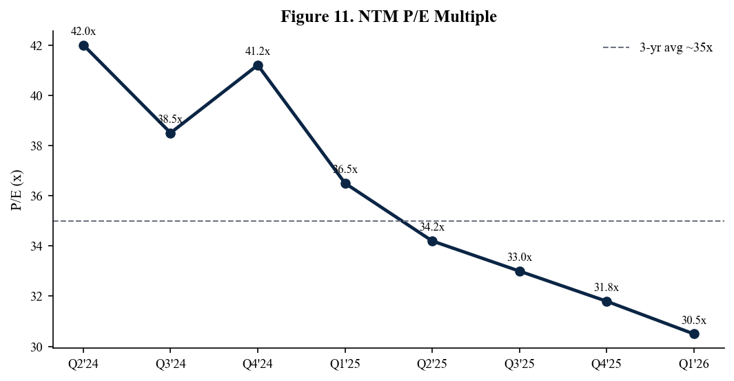
Figure 11. NTM P/E multiple — Amazon trades below its 3-year average.
Sources
- Q1 2026 Press Release — aboutamazon.com/news/company-news/amazon-q1-2026-earnings
- Q1 2026 Investor Relations Page — ir.aboutamazon.com/quarterly-results
- Q1 2026 Earnings Conference Call Webcast — ir.aboutamazon.com/events-and-presentations
- Amazon 10-Q (Q1 2026) — sec.gov/cgi-bin/browse-edgar?action=getcompany&CIK=0001018724&type=10-Q
- Q1 2026 Earnings Call Transcript (Apr 30, 2026) — fool.com/earnings/call-transcripts/
- AWS Backlog and Customer Win Disclosures — aws.amazon.com/blogs/aws
- Amazon Investor Relations — ir.aboutamazon.com
Disclaimer: This report is generated by an AI research assistant for informational purposes only and does not constitute investment advice. Figures reflect publicly disclosed information as of May 2, 2026.

